MLA0105- ARTIFICIAL INTELLIGENCE AND EXPERT SYSTEMS

1) In sliding puzzle, it consists of a 3x3 grid with eight numbered tiles and one empty space. The goal of the
puzzle is to rearrange the tiles from their initial, scrambled state to a goal state where the numbers are
ordered from 1 to 8, with the empty space in the bottom-right corner. Implement the same using python.
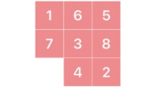

import heapq
# Goal state
GOAL_STATE = ((1, 2, 3),
(4, 5, 6),
(7, 8, 0))
# Possible moves: Up, Down, Left, Right
MOVES = [(-1, 0), (1, 0), (0, -1), (0, 1)]
# Manhattan distance heuristic
def manhattan_distance(state):
distance = 0
for i in range(3):
for j in range(3):
value = state[i][j]
if value != 0:
target_x = (value - 1) // 3
target_y = (value - 1) % 3
distance += abs(target_x - i) + abs(target_y - j)
return distance

# Generate neighbors
def get_neighbors(state):
for i in range(3):
for j in range(3):
if state[i][j] == 0:
x, y = i, j
neighbors = []
for dx, dy in MOVES:
nx, ny = x + dx, y + dy
if 0 <= nx < 3 and 0 <= ny < 3:
new_state = [list(row) for row in state]
new_state[x][y], new_state[nx][ny] = new_state[nx][ny], new_state[x][y]
neighbors.append(tuple(tuple(row) for row in new_state))
return neighbors

# Solve puzzle using A* search
def solve_puzzle(start_state):
start = tuple(tuple(row) for row in start_state)
pq = [(manhattan_distance(start), 0, start)]
visited = set()

while pq:
_, cost, state = heapq.heappop(pq)
if state in visited:
continue
visited.add(state)
if state == GOAL_STATE:
return state
for neighbor in get_neighbors(state):
heapq.heappush(pq, (cost + 1 + manhattan_distance(neighbor), cost + 1, neighbor))
return None

# Print the puzzle state
def print_state(state):
for row in state:
print(' '.join(str(x) if x != 0 else '_' for x in row))
print()

# Take input from user
print("Enter the initial 8-puzzle state (0 for empty tile) row by row, numbers separated by spaces:")
start_state = [list(map(int, input(f"Row {i+1}: ").split())) for i in range(3)]

print("\nInitial State:")
print_state(start_state)

final_state = solve_puzzle(start_state)
if final_state:
print("Final Solved State:")
print_state(final_state)
else:
print("No solution found.")
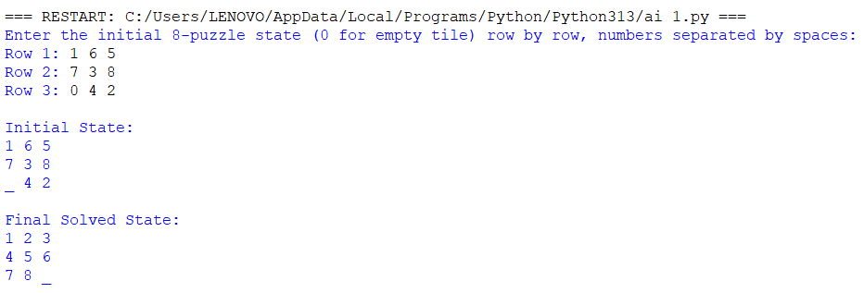

2) The Towers of Hanoi problem involves three pegs (A, B, C) and a number of disks of different sizes that
can slide onto any peg. The puzzle starts with all the disks stacked on one peg in order of decreasing size,
with the largest at the bottom.
The objective of the problem is to move the entire stack to another peg, following these rules:
a) Only one disk can be moved at a time.
b) Each move consists of taking the upper disk from one of the stacks and placing it on top of another
stack.
c) No disk may be placed on top of a smaller disk.
Implement the above Towers of Hanoi problem using Python.
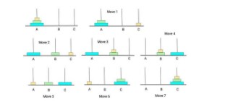
def towers_of_hanoi(n, source, auxiliary, target):
if n == 1:
print(f"Move disk 1 from {source} to {target}")
return
# Move n-1 disks from source to auxiliary peg
towers_of_hanoi(n - 1, source, target, auxiliary)

# Move the remaining disk from source to target
print(f"Move disk {n} from {source} to {target}")

# Move the n-1 disks from auxiliary to target peg
towers_of_hanoi(n - 1, auxiliary, source, target)

# Main Program
num_disks = int(input("Enter the number of disks: "))
print(f"\nSteps to solve Tower of Hanoi with {num_disks} disks:\n")
towers_of_hanoi(num_disks, 'A', 'B', 'C')

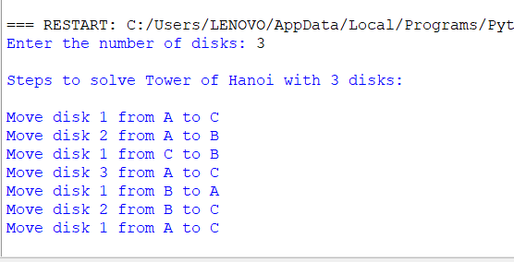

3) Implement a Python program to perform Breadth-First Search (BFS) on a graph. The program should:
• Represent the graph using an adjacency list.
• Start the traversal from a given source node.
• Print the order in which the nodes are visited
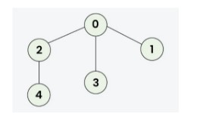
#BFS
from collections import deque

def bfs(graph, start):
visited = []
queue = deque([start])

while queue:
node = queue.popleft()
if node not in visited:
print(node, end=" ")
visited.append(node)
for neighbor in graph.get(node, []):
if neighbor not in visited:
queue.append(neighbor)

# ---- MAIN PROGRAM ----
graph = {}

n = int(input("Enter the number of levels in the graph: "))

print("\nEnter each node and its neighbors.")
print("Example: For node A with neighbors B and C, enter: A B C")
print(" For node 1 with neighbors 2 and 3, enter: 1 2 3\n")

for _ in range(n):
data = input("Enter node and its neighbors: ").split()
node = data[0]
# Convert to int if possible
try:
node = int(node)
except ValueError:
pass

neighbors = []
for val in data[1:]:
try:
neighbors.append(int(val))
except ValueError:
neighbors.append(val)

graph[node] = neighbors

# Display the graph
print("\nGraph (Adjacency List):")
for node, neighbors in graph.items():
print(f"{node} -> {neighbors}")

# BFS Traversal
start = input("\nEnter the starting node: ")
try:
start = int(start)
except ValueError:
pass

if start not in graph:
print("\nInvalid starting node!")
else:
print(f"\nBreadth-First Search traversal starting from node {start}:")
bfs(graph, start)

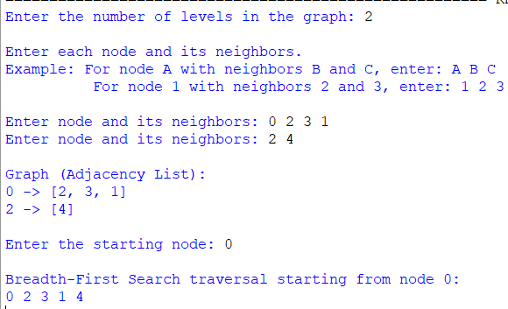
4) The Monkey and Banana problem is a classic artificial intelligence problem where a monkey needs to
navigate through a room to reach a bunch of bananas hanging from the ceiling. The monkey has to move
a box to stand on it to reach the bananas. Implement the above scenario using python.

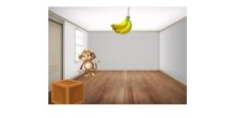
initial_state = {
'monkey': 'A',
'box': 'B',
'monkey_on_box': False,
'has_banana': False
}

goal_state = {
'has_banana': True
}

banana_position = 'C' # Bananas are hanging at position C

def display_state(state):
print(f"Monkey at: {state['monkey']}, Box at: {state['box']}, "
f"On Box: {state['monkey_on_box']}, Has Banana: {state['has_banana']}")

def move(state, position):
state['monkey'] = position
print(f"Monkey moves to {position}")
return state

def push_box(state, position):
if state['monkey'] == state['box']:
state['monkey'] = position
state['box'] = position
print(f"Monkey pushes the box to {position}")
else:
print("Monkey needs to be at the box to push it!")
return state

def climb_box(state):
if state['monkey'] == state['box']:
state['monkey_on_box'] = True
print("Monkey climbs on the box")
else:
print("Monkey must be at the box to climb it!")
return state

def grab_banana(state):
if state['monkey_on_box'] and state['box'] == banana_position:
state['has_banana'] = True
print("Monkey grabs the banana! 🍌")
else:
print("Monkey cannot reach the banana yet.")
return state

# --- Simulation ---
print("Initial State:")
display_state(initial_state)
print("\nActions:")

# Step 1: Move to the box
move(initial_state, 'B')

# Step 2: Push box to bananas
push_box(initial_state, 'C')

# Step 3: Climb onto the box
climb_box(initial_state)

# Step 4: Grab the bananas
grab_banana(initial_state)

# --- Final State ---
print("\nFinal State:")
display_state(initial_state)

if initial_state['has_banana']:
print("\n✅ Goal achieved! Monkey got the bananas!")
else:
print("\n❌ Goal not achieved.")

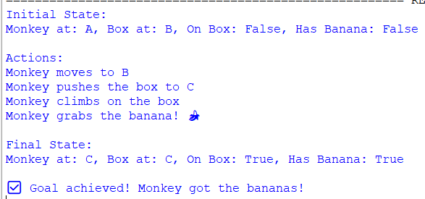
5) Write the python program to place eight queens on an 8 x 8 chessboard in such a way that no two queens
threaten each other. In other words, no two queens can share the same row, column, or diagonal. Use
backtracking to explore different possibilities and ensures that no two queens threaten each other.

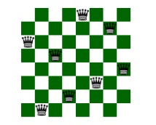
# 8 Queens Problem using Backtracking

N = 8 # Chessboard size (8x8)

def print_solution(board):
"""Display the chessboard with queens placed safely."""
for row in board:
print(" ".join("Q" if x == 1 else "." for x in row))
print("\n")

def is_safe(board, row, col):
"""Check if a queen can be safely placed at board[row][col]."""

# Check this column on upper rows
for i in range(row):
if board[i][col] == 1:
return False

# Check upper left diagonal
for i, j in zip(range(row-1, -1, -1), range(col-1, -1, -1)):
if board[i][j] == 1:
return False

# Check upper right diagonal
for i, j in zip(range(row-1, -1, -1), range(col+1, N)):
if board[i][j] == 1:
return False

return True

def solve_nqueens(board, row):
"""Use backtracking to solve the N Queens problem."""
# Base case: If all queens are placed
if row >= N:
print_solution(board)
return True

success = False
for col in range(N):
if is_safe(board, row, col):
board[row][col] = 1 # Place the queen
success = solve_nqueens(board, row + 1) or success
board[row][col] = 0 # Backtrack (remove the queen)

return success

def solve():
"""Initialize board and trigger solver."""
board = [[0] * N for _ in range(N)]
if not solve_nqueens(board, 0):
print("No solution exists.")
else:
print("All possible solutions found.")

# Run the solver
solve()

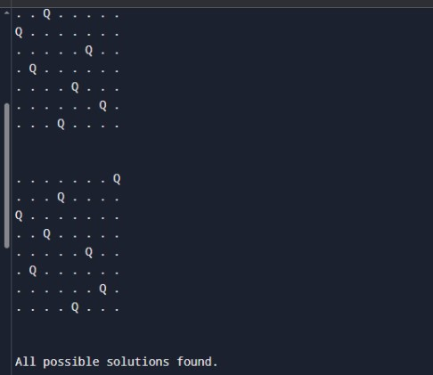

6) Implement a Python program to perform Depth-First Search (DFS) on a graph. The program should:
• Represent the graph using an adjacency list.
• Traverse the graph starting from a given source node.
• Print the order in which the nodes are visited.
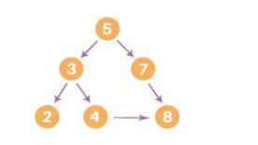
# Depth-First Search (DFS) using adjacency list
# Depth-First Search (DFS) using adjacency list

def dfs(graph, start, visited=None):
if visited is None:
visited = set()

# Mark the current node as visited
visited.add(start)
print(start, end=" ")

# Visit all adjacent nodes
for neighbor in graph[start]:
if neighbor not in visited:
dfs(graph, neighbor, visited)

# Example graph (Adjacency List)
graph = {
5: [3, 7],
3: [2, 4],
7: [8],
2: [],
4: [],
8: []
}
# Starting node
start_node = 5

print("DFS Traversal:")
dfs(graph, start_node)

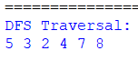

7. Solve the given problem using python. Consider a Water Jug problem: You are given two jugs, a 4-gallon
one and a 3-gallon one. Neither has any measuring marker on it. There is a pump that can be used to fill
the jugs with water. How can you get exactly 2 gallons of water into the 4-gallon jug? Explicit
Assumptions: A jug can be filled from the pump, water can be poured out of a jug onto the ground, water
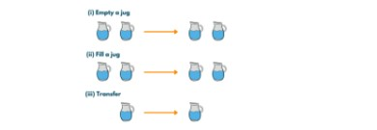
from collections import deque
def water_jug_problem():
jugA, jugB = 4, 3
visited = set()
queue = deque([(0, 0, [])])

while queue:
a, b, path = queue.popleft()
if (a, b) in visited:
continue
visited.add((a, b))
path = path + [(a, b)]
if a == 2:
print("Steps to get exactly 2 gallons in the 4-gallon jug:\n")
for step in path:
print(f"Jug A: {step[0]} gallons, Jug B: {step[1]} gallons")
return

next_states = []
next_states.append((jugA, b))
next_states.append((a, jugB))
next_states.append((0, b))
next_states.append((a, 0))
pour = min(a, jugB - b)
next_states.append((a - pour, b + pour))
pour = min(b, jugA - a)
next_states.append((a + pour, b - pour))

# Add next states to queue
for state in next_states:
if state not in visited:
queue.append((state[0], state[1], path))

print("No solution found.")

water_jug_problem()

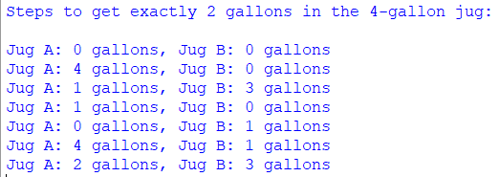

8. Implement a Python program to perform Backward Chaining on a set of Horn clauses. The program
should:
a) Accept a knowledge base defined using Horn clauses (facts and rules).
b) Take a goal (query) as input.
c) Attempt to prove the goal using backward chaining.
d) Print whether the goal can be derived from the knowledge base.

mammal(A) ==> vertebrate(A).
vertebrate(A) ==> animal(A).
vertebrate(A),flying(A) ==> bird(A).
vertebrate("duck").
flying("duck").
mammal("cat").
# ---------------------------
# Knowledge Base
# ---------------------------

# Rules: ("head", ["body1", "body2", ...])
rules = [
("vertebrate(A)", ["mammal(A)"]),
("animal(A)", ["vertebrate(A)"]),
("bird(A)", ["vertebrate(A)", "flying(A)"])
]

# Facts: simple known facts
facts = [
'vertebrate("duck")',
'flying("duck")',
'mammal("cat")'
]

# ---------------------------
# Unification function
# ---------------------------
def unify(term, fact):
"""
Unify a term with a fact.
Returns a substitution dict if successful, else None
"""
if "(" not in term: # simple fact
return {} if term == fact else None

pred1, arg1 = term.split("(")
arg1 = arg1.rstrip(")")
pred2, arg2 = fact.split("(")
arg2 = arg2.rstrip(")")

if pred1 != pred2:
return None

# If term has a variable (uppercase)
if arg1.isupper(): # e.g., A
return {arg1: arg2}
elif arg1 == arg2:
return {}
else:
return None

# ---------------------------
# Backward Chaining Algorithm
# ---------------------------
def backward_chain(goal, facts, rules, visited=None):
if visited is None:
visited = set()

if goal in visited:
return False
visited.add(goal)

# Check if goal is a fact
for fact in facts:
if unify(goal, fact) is not None:
return True

# Check if any rule can derive the goal
for head, body in rules:
substitution = unify(head, goal)
if substitution is not None:
# Apply substitution to body
new_goals = []
for b in body:
if "(" in b:
pred, arg = b.split("(")
arg = arg.rstrip(")")
if arg in substitution:
arg = substitution[arg]
new_goals.append(f"{pred}({arg})")
else:
new_goals.append(b)
# Recursively check all sub-goals
if all(backward_chain(g, facts, rules, visited) for g in new_goals):
return True
return False

# ---------------------------
# Main Program
# ---------------------------
if __name__ == "__main__":
print("Backward Chaining using Horn Clauses\n")
while True:
query = input("Enter the goal to prove (e.g., animal(\"cat\")): ")
result = backward_chain(query, facts, rules)
if result:
print(f"Goal '{query}' can be derived from the knowledge base.\n")
else:
print(f"Goal '{query}' cannot be derived from the knowledge base.\n")

cont = input("Do you want to try another goal? (y/n): ")
if cont.lower() != 'y':
break
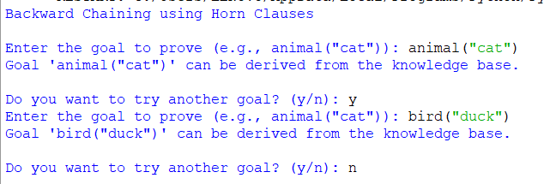

9) Implement a Python program to create a Feedforward Neural Network. The program should:
• Define an input layer, one hidden layer, and an output layer.
• Use activation functions such as Sigmoid or ReLU.
• Perform forward propagation to compute the output values.
• Demonstrate the working of the network on a small sample dataset (e.g., XOR or binary
classification problem).
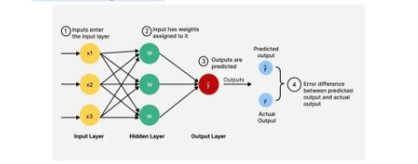
import pygame
import numpy as np
import sys

# ----------------------------------
# Neural Network (Simple Forward Pass)
# ----------------------------------
def sigmoid(x):
return 1 / (1 + np.exp(-x))

class FeedforwardNN:
def __init__(self):
# 2 input → 2 hidden → 1 output
self.w1 = np.random.randn(2, 2)
self.b1 = np.zeros((2,))

self.w2 = np.random.randn(2, 1)
self.b2 = np.zeros((1,))

def forward(self, inputs):
self.z1 = np.dot(inputs, self.w1) + self.b1
self.a1 = sigmoid(self.z1)

self.z2 = np.dot(self.a1, self.w2) + self.b2
self.a2 = sigmoid(self.z2)

return self.a1, self.a2

# ----------------------------------
# Pygame Visualization
# ----------------------------------
pygame.init()
WIDTH, HEIGHT = 800, 500
win = pygame.display.set_mode((WIDTH, HEIGHT))
pygame.display.set_caption("Feedforward Neural Network Visualization")
font = pygame.font.SysFont("Arial", 22, bold=True)

WHITE = (255, 255, 255)
BLUE = (60, 120, 255)
BLACK = (0, 0, 0)

nn = FeedforwardNN()

# Node positions
nodes = {
"input": [(250, 180), (250, 300)],
"hidden": [(450, 180), (450, 300)],
"output": [(650, 240)]
}

def draw_node(x, y, value):
pygame.draw.circle(win, BLUE, (x, y), 40)
text = font.render(f"{value:.2f}", True, WHITE)
win.blit(text, (x - text.get_width()//2, y - text.get_height()//2))

def draw_connection(p1, p2):
pygame.draw.line(win, BLACK, p1, p2, 3)

inputs_list = [
np.array([0, 0]),
np.array([0, 1]),
np.array([1, 0]),
np.array([1, 1])
]

index = 0
clock = pygame.time.Clock()

# ----------------------------------
# Main Loop
# ----------------------------------
while True:
for event in pygame.event.get():
if event.type == pygame.QUIT:
pygame.quit()
sys.exit()

# Cycle through inputs slowly
x_in = inputs_list[index]
hidden_vals, out_val = nn.forward(x_in)

index = (index + 1) % 4
pygame.time.delay(1000)

win.fill(WHITE)

# Draw connections
for i_pos in nodes["input"]:
for h_pos in nodes["hidden"]:
draw_connection(i_pos, h_pos)

for h_pos in nodes["hidden"]:
draw_connection(h_pos, nodes["output"][0])

# Draw nodes with values
draw_node(nodes["input"][0][0], nodes["input"][0][1], x_in[0])
draw_node(nodes["input"][1][0], nodes["input"][1][1], x_in[1])

draw_node(nodes["hidden"][0][0], nodes["hidden"][0][1], hidden_vals[0])
draw_node(nodes["hidden"][1][0], nodes["hidden"][1][1], hidden_vals[1])

draw_node(nodes["output"][0][0], nodes["output"][0][1], out_val[0])

pygame.display.update()
clock.tick(60)
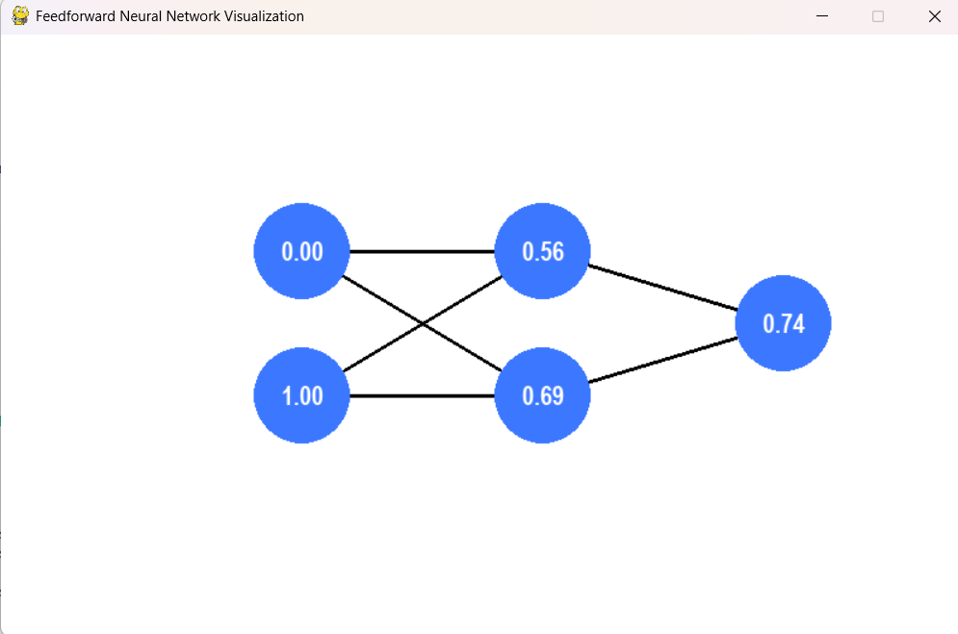

10. Implement a Python program for a Checkers AI agent using the Minimax algorithm with Alpha–Beta
pruning. The program should:
a) Represent the Checkers board and its legal moves.
b) Allow two players (Human vs AI) or (AI vs AI) to play.
c) Use Minimax with Alpha–Beta pruning for the AI’s decision-making.
d) Display the board after every move and declare the winner at the end.

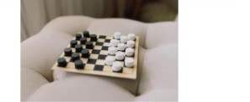
import copy
import math
import random

# -------------------------------------------------------------
# Checkers Game Representation
# -------------------------------------------------------------

EMPTY = "."
RED = "r"
RED_KING = "R"
BLACK = "b"
BLACK_KING = "B"

DIRECTIONS = {
RED: [(-1, -1), (-1, 1)],
BLACK: [(1, -1), (1, 1)],
RED_KING: [(-1,-1),(-1,1),(1,-1),(1,1)],
BLACK_KING: [(-1,-1),(-1,1),(1,-1),(1,1)]
}

def create_board():
board = [[EMPTY]*8 for _ in range(8)]

for i in range(3):
for j in range(8):
if (i+j)%2==1:
board[i][j] = BLACK

for i in range(5,8):
for j in range(8):
if (i+j)%2==1:
board[i][j] = RED

return board

def print_board(board):
print("\n 0 1 2 3 4 5 6 7")
print(" ----------------")
for i, row in enumerate(board):
print(f"{i} | " + " ".join(row))
print()

def in_bounds(r,c):
return 0 <= r < 8 and 0 <= c < 8

def opponent(player):
return RED if player in (BLACK,BLACK_KING) else BLACK

def king(piece):
return piece in (RED_KING, BLACK_KING)

def make_king(piece):
return RED_KING if piece in (RED, RED_KING) else BLACK_KING

# -------------------------------------------------------------
# Move Generation
# -------------------------------------------------------------
def get_all_moves(board, player):
"""Return all legal moves for the current player."""
moves = []
captures = []

for r in range(8):
for c in range(8):
if board[r][c].lower() == player:
caps = get_piece_captures(board, r, c)
if caps:
captures.extend(caps)
else:
moves.extend(get_piece_moves(board, r, c))

return captures if captures else moves

def get_piece_moves(board, r, c):
piece = board[r][c]
moves = []

for dr, dc in DIRECTIONS[piece]:
nr, nc = r + dr, c + dc
if in_bounds(nr, nc) and board[nr][nc] == EMPTY:
moves.append(((r,c),(nr,nc)))

return moves

def get_piece_captures(board, r, c):
piece = board[r][c]
captures = []

for dr, dc in DIRECTIONS[piece]:
mid_r, mid_c = r + dr, c + dc
end_r, end_c = r + 2*dr, c + 2*dc

if (in_bounds(mid_r, mid_c) and in_bounds(end_r, end_c) and
board[mid_r][mid_c].lower() == opponent(piece) and
board[end_r][end_c] == EMPTY):

# Perform capture simulation
new_board = copy.deepcopy(board)
move_piece(new_board, (r,c), (end_r,end_c))
new_board[mid_r][mid_c] = EMPTY

# Chain captures
further = get_piece_captures(new_board, end_r, end_c)
if further:
captures.extend([( (r,c), (end_r,end_c), chain ) for chain in further])
else:
captures.append(((r,c),(end_r,end_c)))

return captures

def move_piece(board, start, end):
(r,c),(nr,nc) = start,end
piece = board[r][c]
board[r][c] = EMPTY

# Promotion
if piece == RED and nr == 0:
piece = RED_KING
if piece == BLACK and nr == 7:
piece = BLACK_KING

board[nr][nc] = piece

# -------------------------------------------------------------
# Winner Check
# -------------------------------------------------------------
def check_winner(board):
red_exists = any(piece in (RED, RED_KING) for row in board for piece in row)
black_exists = any(piece in (BLACK, BLACK_KING) for row in board for piece in row)
if not red_exists:
return "BLACK wins"
if not black_exists:
return "RED wins"
return None

# -------------------------------------------------------------
# Evaluation Function (Heuristic)
# -------------------------------------------------------------
def evaluate(board):
score = 0
for row in board:
for p in row:
if p == RED: score += 1
elif p == RED_KING: score += 2
elif p == BLACK: score -= 1
elif p == BLACK_KING: score -= 2
return score

# -------------------------------------------------------------
# Minimax with Alpha-Beta
# -------------------------------------------------------------
def minimax(board, depth, alpha, beta, maximizing, player):
win = check_winner(board)
if win or depth == 0:
return evaluate(board), None

moves = get_all_moves(board, player)

if not moves:
return evaluate(board), None

best_move = None

if maximizing:
max_eval = -math.inf
for mv in moves:
new_board = simulate_move(board, mv)
ev, _ = minimax(new_board, depth-1, alpha, beta, False, opponent(player))
if ev > max_eval:
max_eval = ev
best_move = mv

alpha = max(alpha, ev)
if beta <= alpha:
break
return max_eval, best_move

else:
min_eval = math.inf
for mv in moves:
new_board = simulate_move(board, mv)
ev, _ = minimax(new_board, depth-1, alpha, beta, True, opponent(player))
if ev < min_eval:
min_eval = ev
best_move = mv

beta = min(beta, ev)
if beta <= alpha:
break
return min_eval, best_move

def simulate_move(board, move):
new_board = copy.deepcopy(board)

if len(move) == 2:
# Normal move
move_piece(new_board, move[0], move[1])
else:
# Capture
(r,c),(nr,nc), chain = move
move_piece(new_board, (r,c), (nr,nc))
mid_r = (r+nr)//2
mid_c = (c+nc)//2
new_board[mid_r][mid_c] = EMPTY
return new_board

# -------------------------------------------------------------
# Main Game Loop
# -------------------------------------------------------------
def play_game():
board = create_board()
print_board(board)

mode = input("Choose mode (1 = Human vs AI, 2 = AI vs AI): ")

current_player = RED

while True:
winner = check_winner(board)
if winner:
print(winner)
break

print(f"{current_player.upper()}'s turn")
print_board(board)

moves = get_all_moves(board, current_player)

if not moves:
print(f"{opponent(current_player).upper()} wins!")
break

if mode == "1" and current_player == RED:
# HUMAN MOVE
print("Available moves (start_r start_c end_r end_c):")
for mv in moves:
print(mv)

sr = int(input("Start row: "))
sc = int(input("Start col: "))
er = int(input("End row: "))
ec = int(input("End col: "))

chosen = ((sr,sc),(er,ec))
else:
print("AI thinking...")
_, chosen = minimax(board, 4, -math.inf, math.inf, True, current_player)

# Apply the move
board = simulate_move(board, chosen)

current_player = opponent(current_player)

# -------------------------------------------------------------
# Run the game
# -------------------------------------------------------------
play_game()

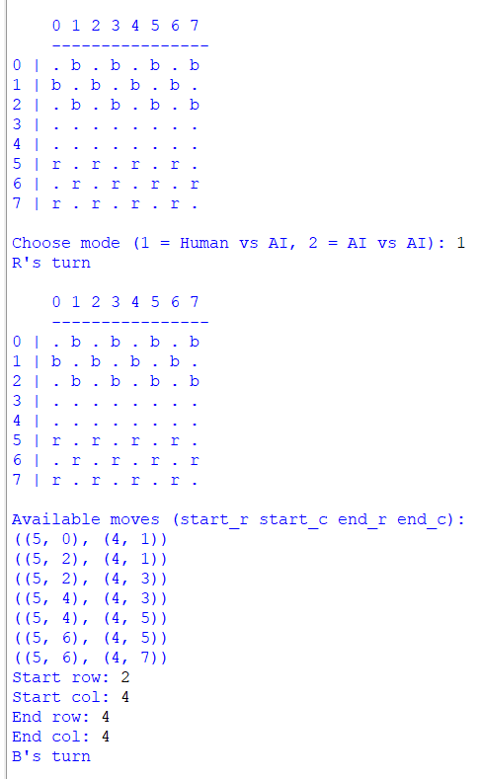
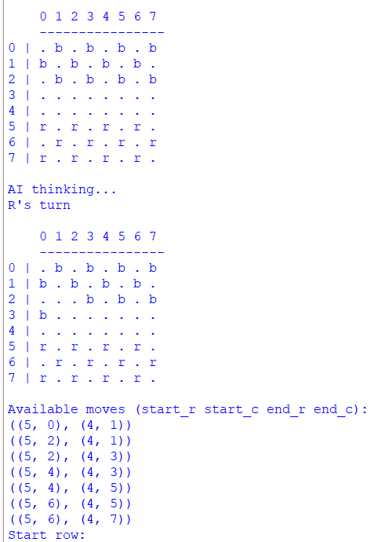

11. Implement a Python program to build and evaluate a Decision Tree classifier.
The program should :
a) Take a dataset as input from the given figure.
b) Build the Decision Tree using a splitting criterion.
c) Display the tree structure in a readable form (rules or indented hierarchy).
d) Classify new instances based on the trained tree.
e) Print the accuracy of the model on test data.
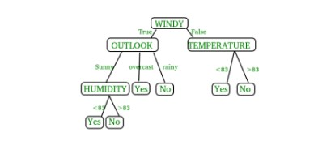
# Dataset
dataset = [
['Sunny', 'Hot', 'High', 'False', 'No'],
['Sunny', 'Hot', 'High', 'True', 'No'],
['Overcast', 'Hot', 'High', 'False', 'Yes'],
['Rainy', 'Mild', 'High', 'False', 'Yes'],
['Rainy', 'Cool', 'Normal', 'False', 'Yes'],
['Rainy', 'Cool', 'Normal', 'True', 'No'],
['Overcast', 'Cool', 'Normal', 'True', 'Yes'],
['Sunny', 'Mild', 'High', 'False', 'No'],
['Sunny', 'Cool', 'Normal', 'False', 'Yes'],
['Rainy', 'Mild', 'Normal', 'False', 'Yes'],
['Sunny', 'Mild', 'Normal', 'True', 'Yes'],
['Overcast', 'Mild', 'High', 'True', 'Yes'],
['Overcast', 'Hot', 'Normal', 'False', 'Yes'],
['Rainy', 'Mild', 'High', 'True', 'No']
]

features = ['Outlook', 'Temperature', 'Humidity', 'Windy']

import math

# Step 1: Entropy function
def entropy(rows):
total = len(rows)
yes = len([r for r in rows if r[-1] == 'Yes'])
no = total - yes
if yes == 0 or no == 0:
return 0
p1 = yes / total
p2 = no / total
return -p1 * math.log2(p1) - p2 * math.log2(p2)

# Step 2: Split dataset
def split_dataset(rows, column, value):
set1 = [r for r in rows if r[column] == value]
set2 = [r for r in rows if r[column] != value]
return set1, set2

# Step 3: Find best split
def best_split(rows):
best_gain = 0
best_column = None
best_value = None
current_entropy = entropy(rows)
n_features = len(rows[0]) - 1

for col in range(n_features):
values = set([r[col] for r in rows])
for v in values:
set1, set2 = split_dataset(rows, col, v)
if len(set1) == 0 or len(set2) == 0:
continue

p = len(set1) / len(rows)
gain = current_entropy - p * entropy(set1) - (1 - p) * entropy(set2)

if gain > best_gain:
best_gain = gain
best_column = col
best_value = v

return best_gain, best_column, best_value

# Step 4: Node class
class DecisionNode:
def __init__(self, column=None, value=None, true_branch=None, false_branch=None, result=None):
self.column = column
self.value = value
self.true_branch = true_branch
self.false_branch = false_branch
self.result = result

# Step 5: Build tree
def build_tree(rows):
gain, column, value = best_split(rows)
if gain == 0:
yes = len([r for r in rows if r[-1] == 'Yes'])
no = len(rows) - yes
return DecisionNode(result='Yes' if yes >= no else 'No')

set1, set2 = split_dataset(rows, column, value)
true_branch = build_tree(set1)
false_branch = build_tree(set2)

return DecisionNode(column, value, true_branch, false_branch)

# Step 6: Print tree
def print_tree(node, spacing=""):
if node.result is not None:
print(spacing + "Predict:", node.result)
return

print(f"{spacing}{features[node.column]} == {node.value}?")
print(spacing + "-> True:")
print_tree(node.true_branch, spacing + " ")
print(spacing + "-> False:")
print_tree(node.false_branch, spacing + " ")

# Step 7: Classify new instance
def classify(observation, node):
if node.result is not None:
return node.result

if observation[node.column] == node.value:
return classify(observation, node.true_branch)
else:
return classify(observation, node.false_branch)

# Step 8: Build the tree
tree = build_tree(dataset)

print("\n=== DECISION TREE STRUCTURE ===\n")
print_tree(tree)

# Step 9: Test classification
test_data = ['Rainy', 'Mild', 'Normal', 'False'] # Expected Yes
prediction = classify(test_data, tree)

print("\nPrediction for", test_data, "->", prediction)

# Step 10: Accuracy test
correct = 0
for row in dataset:
pred = classify(row[:-1], tree)
if pred == row[-1]:
correct += 1

accuracy = correct / len(dataset) * 100
print("\nAccuracy on training data:", accuracy, "%")
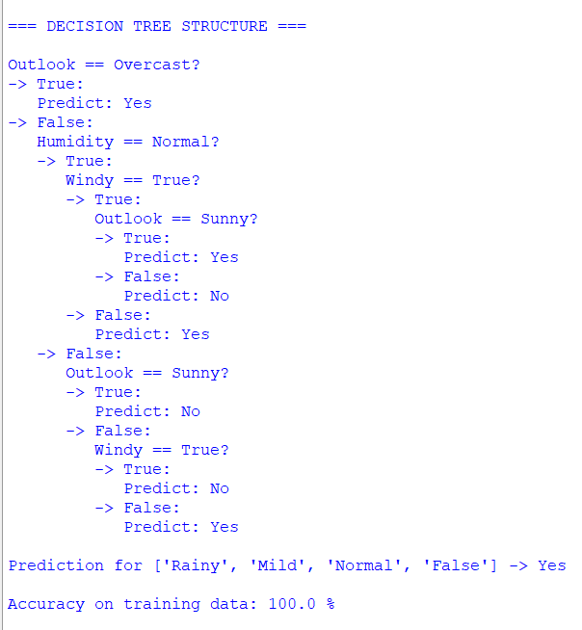
12. It's a river-crossing puzzle that involves three missionaries and three cannibals who need to cross a river
from one side to another. The problem comes with certain constraints:
a) There is a boat that can carry at most two people at a time.
b) On either side of the river, if the number of cannibals ever exceeds the number of missionaries, the
cannibals will eat the missionaries, and the mission will fail.
c) The goal is to find a series of moves that allow all the missionaries and cannibals to cross the river
safely. Implement the scenario using Python.
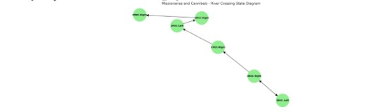
from collections import deque
start_state = (3, 3, 'left')
goal_state = (0, 0, 'right')
def is_valid_state(m_left, c_left, boat_pos):
m_right = 3 - m_left
c_right = 3 - c_left
if not (0 <= m_left <= 3 and 0 <= c_left <= 3):
return False
if (m_left > 0 and m_left < c_left) or (m_right > 0 and m_right < c_right):
return False
return True
def get_successors(state):
m_left, c_left, boat_pos = state
successors = []
moves = [(1, 0), (2, 0), (0, 1), (0, 2), (1, 1)]

for m_move, c_move in moves:
if boat_pos == 'left':
new_state = (m_left - m_move, c_left - c_move, 'right')
else:
new_state = (m_left + m_move, c_left + c_move, 'left')

if is_valid_state(*new_state):
successors.append(new_state)

return successors

# BFS to find the shortest path
def bfs(start, goal):
queue = deque([(start, [start])])
visited = set()

while queue:
current_state, path = queue.popleft()

if current_state == goal:
return path

visited.add(current_state)

for next_state in get_successors(current_state):
if next_state not in visited:
queue.append((next_state, path + [next_state]))

return None

# Run the BFS search
solution = bfs(start_state, goal_state)

# Print the solution
if solution:
print("Solution found! Sequence of states:")
for step in solution:
print(step)
else:
print("No solution found.")
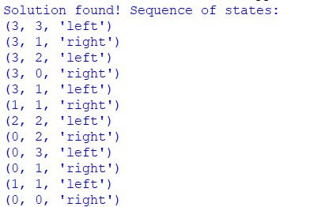

13. Implement a Python program to simulate the Tic Tac Toe game. The program should:
a) Represent the 3×3 game board.
b) Allow a human player to play against an AI player.
c) Print the board after each move.
d) Declare the winner or draw at the end of the game

import random

def print_board(board):
for row in board:
print(" | ".join(row))
print("-" * 9)

def check_winner(board, player):
# Check rows and columns
for i in range(3):
if all(board[i][j] == player for j in range(3)): # row
return True
if all(board[j][i] == player for j in range(3)): # column
return True

# Check diagonals
if all(board[i][i] == player for i in range(3)): # main diagonal
return True
if all(board[i][2 - i] == player for i in range(3)): # anti-diagonal
return True

return False

def board_full(board):
return all(board[i][j] != ' ' for i in range(3) for j in range(3))

def human_move(board):
while True:
try:
move = input("Enter your move as row and column (0 1 2) separated by space: ")
row, col = map(int, move.split())
if row in range(3) and col in range(3) and board[row][col] == ' ':
board[row][col] = 'X'
break
else:
print("Invalid move, cell already occupied or out of bounds.")
except:
print("Invalid input. Please enter two numbers separated by space.")

def ai_move(board):
# Simple AI: random move
available = [(i, j) for i in range(3) for j in range(3) if board[i][j] == ' ']
if available:
row, col = random.choice(available)
board[row][col] = 'O'

def tic_tac_toe():
board = [[' ' for _ in range(3)] for _ in range(3)]
print_board(board)

while True:
human_move(board)
print_board(board)

if check_winner(board, 'X'):
print("Human wins!")
break

if board_full(board):
print("It's a draw!")
break

ai_move(board)
print("AI's move:")
print_board(board)

if check_winner(board, 'O'):
print("AI wins!")
break

if board_full(board):
print("It's a draw!")
break

if __name__ == "__main__":
tic_tac_toe()

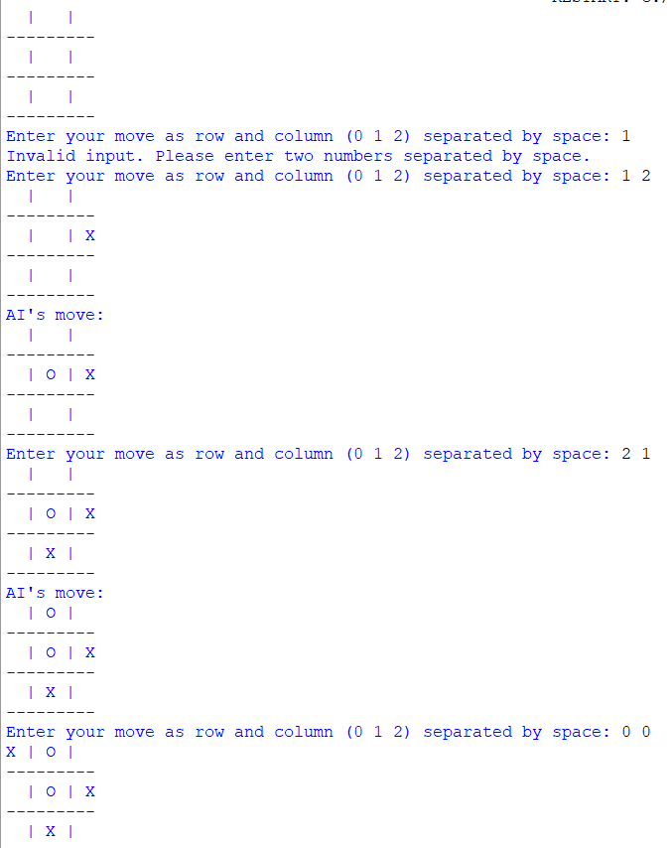

14. Imagine you have a simple autonomous vacuum cleaner, which can move around in a grid-based
environment. The grid is divided into cells, some of which are dirty, and some are clean. The vacuum
cleaner can move in four directions: up, down, left, and right. Its primary task is to clean all the dirty cells
while minimizing its movements. Implement the above AI problem using python.

import pygame
import random
import sys

# Initialize pygame
pygame.init()

# Grid setup
ROWS, COLS = 5, 5
CELL_SIZE = 100
WIDTH, HEIGHT = COLS * CELL_SIZE, ROWS * CELL_SIZE
FPS = 10

# Colors
WHITE = (240, 240, 240)
BLACK = (0, 0, 0)
GREEN = (0, 200, 0)
BROWN = (139, 69, 19)
BLUE = (0, 120, 255)
GRAY = (180, 180, 180)

# Initialize window
screen = pygame.display.set_mode((WIDTH, HEIGHT + 80))
pygame.display.set_caption("🧹 Autonomous Vacuum Cleaner Game")

font = pygame.font.SysFont("arial", 24)

# Initialize grid with random dirty cells
grid = [['.' for _ in range(COLS)] for _ in range(ROWS)]
num_dirty = random.randint(5, 8)
dirty_cells = random.sample([(r, c) for r in range(ROWS) for c in range(COLS)], num_dirty)
for r, c in dirty_cells:
grid[r][c] = 'D'

# Place vacuum at random position
vacuum_r, vacuum_c = random.choice([(r, c) for r in range(ROWS) for c in range(COLS)])
grid[vacuum_r][vacuum_c] = 'V'

moves = 0

def draw_grid():
"""Draws the game grid and elements."""
for r in range(ROWS):
for c in range(COLS):
x, y = c * CELL_SIZE, r * CELL_SIZE
pygame.draw.rect(screen, GRAY, (x, y, CELL_SIZE, CELL_SIZE), 1)

if grid[r][c] == 'D':
pygame.draw.circle(screen, BROWN, (x + CELL_SIZE//2, y + CELL_SIZE//2), 20)
elif grid[r][c] == 'V':
pygame.draw.rect(screen, BLUE, (x + 25, y + 25, 50, 50), border_radius=10)

# Draw text area
pygame.draw.rect(screen, WHITE, (0, HEIGHT, WIDTH, 80))
dirty_count = sum(row.count('D') for row in grid)
text1 = font.render(f"Dirty Cells Left: {dirty_count}", True, BLACK)
text2 = font.render(f"Moves Taken: {moves}", True, BLACK)
screen.blit(text1, (20, HEIGHT + 10))
screen.blit(text2, (20, HEIGHT + 40))

def move_vacuum(dr, dc):
"""Moves the vacuum cleaner on the grid."""
global vacuum_r, vacuum_c, moves

new_r = vacuum_r + dr
new_c = vacuum_c + dc
if 0 <= new_r < ROWS and 0 <= new_c < COLS:
# Clear old position
grid[vacuum_r][vacuum_c] = '.'
# Move to new position
vacuum_r, vacuum_c = new_r, new_c
# Clean if dirty
if grid[new_r][new_c] == 'D':
grid[new_r][new_c] = 'V'
else:
grid[new_r][new_c] = 'V'
moves += 1

# Main game loop
clock = pygame.time.Clock()
running = True
while running:
screen.fill(WHITE)
draw_grid()
pygame.display.flip()

dirty_left = sum(row.count('D') for row in grid)
if dirty_left == 0:
screen.fill(WHITE)
win_text = font.render("✅ All cells are clean! Well done!", True, GREEN)
screen.blit(win_text, (60, HEIGHT // 2 - 30))
pygame.display.flip()
pygame.time.wait(2500)
running = False
continue

for event in pygame.event.get():
if event.type == pygame.QUIT:
pygame.quit()
sys.exit()
elif event.type == pygame.KEYDOWN:
if event.key == pygame.K_UP:
move_vacuum(-1, 0)
elif event.key == pygame.K_DOWN:
move_vacuum(1, 0)
elif event.key == pygame.K_LEFT:
move_vacuum(0, -1)
elif event.key == pygame.K_RIGHT:
move_vacuum(0, 1)

clock.tick(FPS)

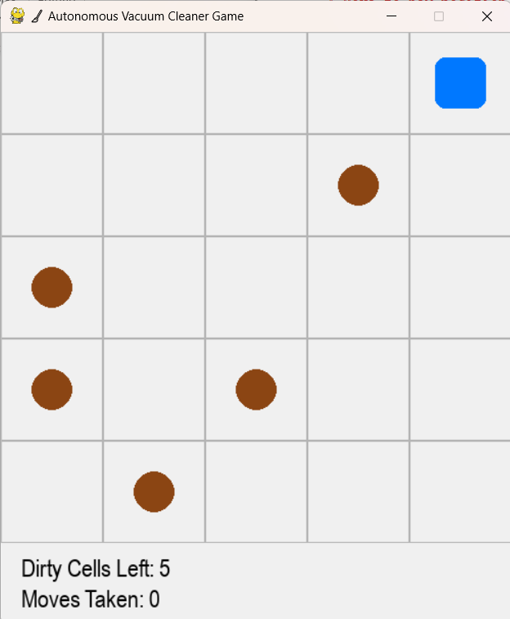

15. Implement a Python program to solve the N-Queens problem using Hill Climbing. The program should:
a) Represent a state as positions of N queens (one per column).
b) Define a cost function = number of attacking pairs of queens.
c) Generate neighbors by moving one queen within its column to a different row.
d) Move to the best neighbor if it strictly improves the cost.
e) Stop when no better neighbor exists (local optimum).
f) (Optional) Use random restarts to increase the chance of finding a global optimum.
g) Print the final board, the final cost, and whether a valid solution (cost = 0) was found.
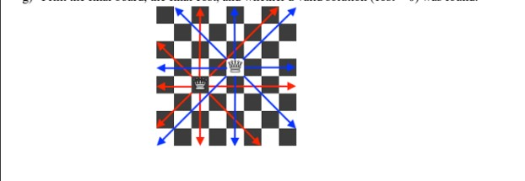
n queens problem using hill climbing
import random

def print_board(state):
n = len(state)
for row in range(n):
line = ""
for col in range(n):
if state[col] == row:
line += "Q "
else:
line += ". "
print(line)
print()

# Cost function: number of attacking pairs
def compute_cost(state):
attacks = 0
n = len(state)
for i in range(n):
for j in range(i + 1, n):
if state[i] == state[j] or abs(state[i] - state[j]) == abs(i - j):
attacks += 1
return attacks

# Generate all neighbors by moving one queen in its column
def get_neighbors(state):
neighbors = []
n = len(state)
for col in range(n):
for row in range(n):
if row != state[col]:
new_state = list(state)
new_state[col] = row
neighbors.append(new_state)
return neighbors

# Hill Climbing Algorithm
def hill_climbing(n, max_restarts=10):
best_overall = None
best_cost = float("inf")

for restart in range(max_restarts):
current = [random.randint(0, n - 1) for _ in range(n)]
current_cost = compute_cost(current)

while True:
neighbors = get_neighbors(current)
neighbor_costs = [compute_cost(neighbor) for neighbor in neighbors]
min_cost = min(neighbor_costs)
if min_cost >= current_cost: # Local optimum
break
best_neighbor = neighbors[neighbor_costs.index(min_cost)]
current, current_cost = best_neighbor, min_cost

# Track the best solution across restarts
if current_cost < best_cost:
best_cost = current_cost
best_overall = current

# If a valid solution is found
if best_cost == 0:
break

print("Final Board:")
print_board(best_overall)
print("Final Cost:", best_cost)
if best_cost == 0:
print("✅ Solution Found!")
else:
print("⚠ Local Optimum Reached.")

# Run the algorithm
n = 8 # You can change N here
hill_climbing(n)

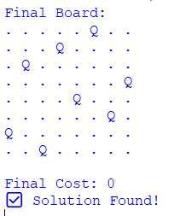
16. You are given a map with regions (represented as nodes or vertices) that need to be colored such that no
adjacent regions have the same color. The goal is to find a valid coloring for the entire map. Implement in
graph using python.
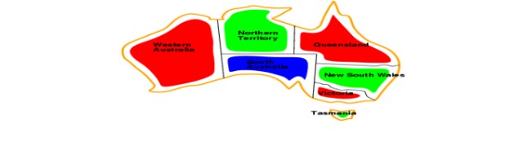
import pygame
import sys
import math

# --- Initialize Pygame ---
pygame.init()
WIDTH, HEIGHT = 800, 600
screen = pygame.display.set_mode((WIDTH, HEIGHT))
pygame.display.set_caption("Map Coloring Game")

FONT = pygame.font.SysFont("arial", 24)
SMALL_FONT = pygame.font.SysFont("arial", 18)

# --- Colors ---
WHITE = (255, 255, 255)
BLACK = (0, 0, 0)
GRAY = (200, 200, 200)
RED = (255, 80, 80)
GREEN = (100, 255, 100)
BLUE = (80, 150, 255)
YELLOW = (255, 255, 100)
COLORS = {"Red": RED, "Green": GREEN, "Blue": BLUE, "Yellow": YELLOW}
color_names = list(COLORS.keys())

# --- Graph (Map) Definition ---
graph = {
'A': ['B', 'C', 'D'],
'B': ['A', 'C', 'E'],
'C': ['A', 'B', 'D', 'E'],
'D': ['A', 'C', 'E'],
'E': ['B', 'C', 'D']
}

# --- Node positions (for drawing) ---
positions = {
'A': (200, 200),
'B': (400, 100),
'C': (400, 300),
'D': (600, 200),
'E': (500, 400)
}

# --- Node colors ---
node_colors = {node: None for node in graph}
selected_color = "Red"

# --- Function to draw the graph ---
def draw_graph():
screen.fill(WHITE)

# Draw edges
for node, neighbors in graph.items():
for neighbor in neighbors:
start = positions[node]
end = positions[neighbor]
pygame.draw.line(screen, BLACK, start, end, 2)

# Draw nodes
for node, (x, y) in positions.items():
color = node_colors[node]
pygame.draw.circle(screen, BLACK, (x, y), 40)
pygame.draw.circle(screen, color if color else GRAY, (x, y), 35)
text = FONT.render(node, True, BLACK)
screen.blit(text, (x - 10, y - 12))

# Draw color palette
pygame.draw.rect(screen, GRAY, (50, 450, 700, 100), border_radius=15)
label = FONT.render("Select Color:", True, BLACK)
screen.blit(label, (60, 460))

for i, cname in enumerate(color_names):
rect = pygame.Rect(220 + i * 120, 460, 60, 60)
pygame.draw.rect(screen, COLORS[cname], rect)
if cname == selected_color:
pygame.draw.rect(screen, BLACK, rect, 4)

txt = SMALL_FONT.render(cname, True, BLACK)
screen.blit(txt, (220 + i * 120, 525))

# Display check result
result_text = check_coloring()
result_label = FONT.render(result_text, True, BLACK)
screen.blit(result_label, (300, 550))

pygame.display.flip()

# --- Check coloring validity ---
def check_coloring():
for node, neighbors in graph.items():
for n in neighbors:
if node_colors[node] and node_colors[n] == node_colors[node]:
return "❌ Invalid Coloring!"
if all(node_colors[n] for n in node_colors):
return "✅ Valid Coloring!"
return "🟡 In Progress..."

# --- Detect if click is inside node ---
def get_clicked_node(pos):
for node, (x, y) in positions.items():
if math.dist(pos, (x, y)) < 40:
return node
return None

# --- Main Loop ---
running = True
while running:
draw_graph()
for event in pygame.event.get():
if event.type == pygame.QUIT:
running = False

# Color selection
if event.type == pygame.MOUSEBUTTONDOWN:
mx, my = event.pos
# Check if clicked on color palette
for i, cname in enumerate(color_names):
rect = pygame.Rect(220 + i * 120, 460, 60, 60)
if rect.collidepoint(mx, my):
selected_color = cname

# Check if clicked on node
node = get_clicked_node((mx, my))
if node:
node_colors[node] = COLORS[selected_color]

pygame.quit()
sys.exit()
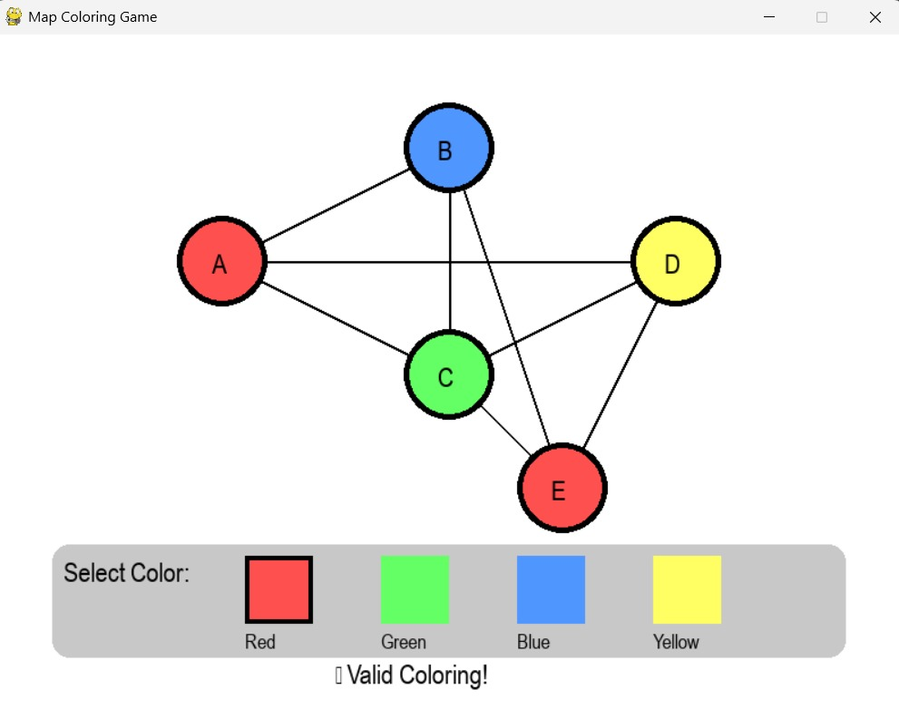
17. Consider a game which has 4 final states and paths to reach final state are from root to 4 leaves of a
perfect binary tree as shown below. Assume you are the maximizing player and you get the first chance
to move, i.e., you are at the root and your opponent at next level. Using python create the program,
which move you would make as a maximizing player considering that your opponent also plays
optimally?
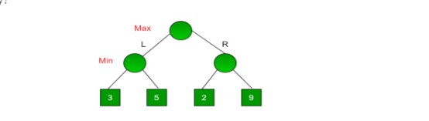
# Minimax Algorithm Example

def minimax(depth, node_index, is_maximizing, values):
"""
Recursive function to apply the minimax algorithm.

depth: current depth in the game tree
node_index: index of the current node
is_maximizing: True if it's the maximizing player's turn, False for minimizing player
values: list of leaf node values
"""
# Base case: if we reach a leaf node
if depth == 2:
return values[node_index]

# If it's the maximizing player's turn
if is_maximizing:
return max(
minimax(depth + 1, node_index * 2, False, values),
minimax(depth + 1, node_index * 2 + 1, False, values)
)
# If it's the minimizing player's turn
else:
return min(
minimax(depth + 1, node_index * 2, True, values),
minimax(depth + 1, node_index * 2 + 1, True, values)
)

# ----------------------------------------------------------
# Leaf nodes (final states)
values = [3, 5, 2, 9]

# Depth of tree = 2 (Root -> Min -> Leaf)
optimal_value = minimax(0, 0, True, values)
print("The optimal value for the maximizing player is:", optimal_value)

# ----------------------------------------------------------
# Determine which move (L or R) the maximizing player should take
left_subtree = min(values[0], values[1]) # Min node under Left
right_subtree = min(values[2], values[3]) # Min node under Right

best_move = "Left" if max(left_subtree, right_subtree) == left_subtree else "Right"
print("The maximizing player should choose:", best_move)

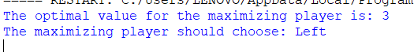

18. Implement a Python program to solve a pathfinding problem using the A* algorithm.
The program should:
a) Represent the environment as a graph or a grid with weighted edges.
b) Take a start node and a goal node as inputs.
c) Use a suitable heuristic function (e.g., Manhattan distance for grids, straight-line distance for
graphs).
d) Explore nodes using the A* evaluation function.
e) Print the order of node expansion and the final optimal path with its total cost.
f) Start Node: A Goal Node: F Nodes: A, B, C, D, E, F Edges with weights: (A, B, 1), (A, C, 4),
(B, D, 3), (B, E, 5), (C, F, 2), (D, F, 1), (D, E, 1), (E, F, 2).
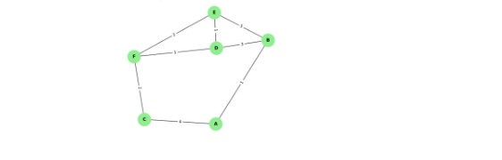
import pygame
import sys
import math
import heapq

# --- Initialize Pygame ---
pygame.init()
WIDTH, HEIGHT = 800, 600
screen = pygame.display.set_mode((WIDTH, HEIGHT))
pygame.display.set_caption("A* Pathfinding Game")

FONT = pygame.font.SysFont("arial", 24)
SMALL_FONT = pygame.font.SysFont("arial", 18)

# --- Colors ---
WHITE = (255, 255, 255)
BLACK = (0, 0, 0)
GRAY = (200, 200, 200)
BLUE = (80, 150, 255)
GREEN = (100, 255, 100)
YELLOW = (255, 255, 100)
ORANGE = (255, 180, 80)
PURPLE = (180, 100, 255)
RED = (255, 80, 80)

# --- Graph Definition ---
graph = {
'A': {'B': 1, 'C': 4},
'B': {'A': 1, 'D': 3, 'E': 5},
'C': {'A': 4, 'F': 2},
'D': {'B': 3, 'E': 1, 'F': 1},
'E': {'B': 5, 'D': 1, 'F': 2},
'F': {'C': 2, 'D': 1, 'E': 2}
}

positions = {
'A': (150, 250),
'B': (300, 150),
'C': (300, 350),
'D': (500, 150),
'E': (500, 350),
'F': (650, 250)
}

start_node = None
goal_node = None

# --- Heuristic ---
def heuristic(n1, n2):
(x1, y1), (x2, y2) = positions[n1], positions[n2]
return math.hypot(x2 - x1, y2 - y1)

# --- A* Algorithm ---
def astar(start, goal):
open_heap = []
heapq.heappush(open_heap, (0, start))
came_from = {}
g_score = {node: float('inf') for node in graph}
g_score[start] = 0
f_score = {node: float('inf') for node in graph}
f_score[start] = heuristic(start, goal)
visited_order = []

while open_heap:
current = heapq.heappop(open_heap)[1]
visited_order.append(current)

if current == goal:
break

for neighbor, weight in graph[current].items():
tentative_g = g_score[current] + weight
if tentative_g < g_score[neighbor]:
came_from[neighbor] = current
g_score[neighbor] = tentative_g
f_score[neighbor] = tentative_g + heuristic(neighbor, goal)
heapq.heappush(open_heap, (f_score[neighbor], neighbor))

path = []
node = goal
if node not in came_from and node != start:
return visited_order, [], float('inf')
while node in came_from:
path.insert(0, node)
node = came_from[node]
path.insert(0, start)
return visited_order, path, g_score[goal]

# --- Draw Graph ---
def draw_graph(visited=set(), path=set()):
screen.fill(WHITE)

# Draw edges
for node, neighbors in graph.items():
for neighbor, weight in neighbors.items():
start_pos = positions[node]
end_pos = positions[neighbor]
pygame.draw.line(screen, GRAY, start_pos, end_pos, 3)
mid_x = (start_pos[0] + end_pos[0]) // 2
mid_y = (start_pos[1] + end_pos[1]) // 2
text = SMALL_FONT.render(str(weight), True, BLACK)
screen.blit(text, (mid_x - 10, mid_y - 10))

# Draw nodes
for node, (x, y) in positions.items():
color = BLUE
if node in visited:
color = YELLOW
if node in path:
color = GREEN
if node == start_node:
color = ORANGE
if node == goal_node:
color = PURPLE
pygame.draw.circle(screen, BLACK, (x, y), 40)
pygame.draw.circle(screen, color, (x, y), 35)
text = FONT.render(node, True, BLACK)
screen.blit(text, (x - 10, y - 12))

# Instructions
instruction = "Click Start Node" if not start_node else \
"Click Goal Node" if not goal_node else "Pathfinding..."
text_inst = FONT.render(instruction, True, RED)
screen.blit(text_inst, (50, 20))

pygame.display.flip()

# --- Detect clicked node ---
def get_clicked_node(pos):
for node, (x, y) in positions.items():
if math.dist(pos, (x, y)) < 40:
return node
return None

# --- Main Loop ---
running = True
visited_order, final_path, cost = [], [], 0
step = 0 # animation step

while running:
draw_graph(set(visited_order[:step]), set(final_path[:step]))
for event in pygame.event.get():
if event.type == pygame.QUIT:
running = False

if event.type == pygame.MOUSEBUTTONDOWN:
clicked = get_clicked_node(event.pos)
if clicked:
if not start_node:
start_node = clicked
elif not goal_node:
goal_node = clicked
visited_order, final_path, cost = astar(start_node, goal_node)
print("Node Expansion Order:", " → ".join(visited_order))
print("Final Path:", " → ".join(final_path))
print(f"Total Cost: {cost}")
step = 0 # reset animation

if start_node and goal_node and step < len(visited_order):
step += 1
pygame.time.delay(500)

pygame.quit()
sys.exit()
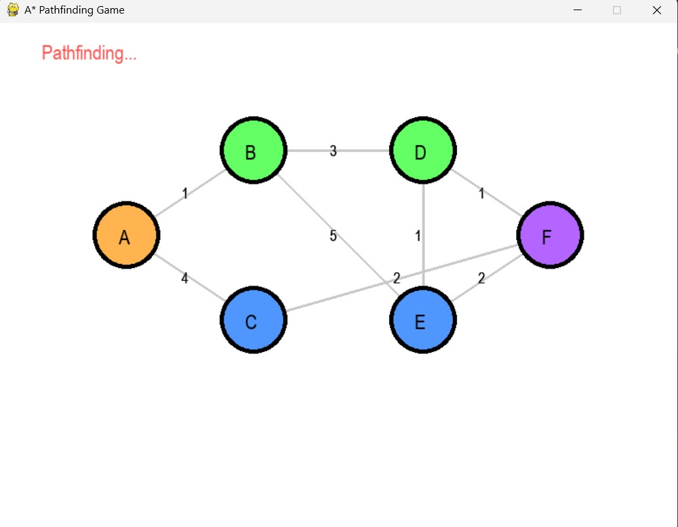

19. Given a list of cities and the distances between each pair of cities, the objective is to find the shortest
possible route that visits each city exactly once and returns to the original city (the salesman's starting
point). Implement the scenario using python.

from itertools import permutations
n = int(input("Enter the number of cities: "))
cities = []
for i in range(n):
city = input(f"Enter city name {i + 1}: ")
cities.append(city)
graph = {}
for city in cities:
graph[city] = {}
print("\nEnter the distances between each pair of cities:")
for i in range(n):
for j in range(i + 1, n):
dist = int(input(f"Distance between {cities[i]} and {cities[j]}: "))
graph[cities[i]][cities[j]] = dist
graph[cities[j]][cities[i]] = dist
start = input("\nEnter the starting city: ")
shortest_distance = float('inf')
best_route = []
for perm in permutations([city for city in cities if city != start]):
route = [start] + list(perm) + [start]
distance = 0

for i in range(len(route) - 1):
distance += graph[route[i]][route[i + 1]]

if distance < shortest_distance:
shortest_distance = distance
best_route = route
print("\nShortest Route:", " -> ".join(best_route))
print("Total Distance:", shortest_distance)

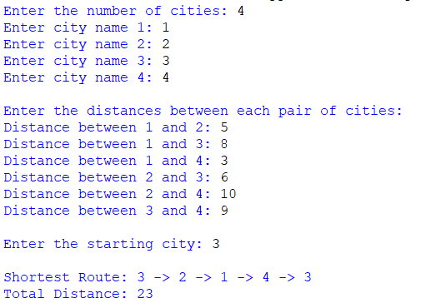

20. Implement a Python program to solve a simple scheduling problem using the Simulated Annealing
Algorithm. The program should:
a) Define a set of tasks and available time slots (e.g., 6 tasks, 3 time slots).
b) Represent a schedule as an assignment of tasks to time slots.
c) Define a cost function that penalizes conflicts (e.g., overlapping tasks or exceeding slot capacity).
d) Start with a random schedule and iteratively propose small changes (neighbor solutions).
e) Accept better solutions always; accept worse solutions with probability exp(-ΔE / T) where T is the
temperature.
f) Implement a cooling schedule that gradually decreases temperature.
g) Print the best schedule found and its cost.
import random
import math
from collections import defaultdict

random.seed(42)

# ----------------------------
# Problem definition
# ----------------------------
tasks = ["A", "B", "C", "D", "E", "F"]
num_slots = 3
slot_capacity = 2 # max allowed tasks per slot (soft constraint)

# Define conflict pairs (these tasks should not be scheduled in the same slot)
# For example: A conflicts with B, C conflicts with D, E conflicts with F
conflicts = {("A","B"), ("B","A"), ("C","D"), ("D","C"), ("E","F"), ("F","E")}

# Weights in cost function
WEIGHT_CONFLICT = 10 # penalty per conflicting pair in same slot
WEIGHT_CAPACITY = 5 # penalty per task exceeding slot capacity
WEIGHT_LOAD_IMBALANCE = 1 # optional: penalty for load imbalance across slots

# ----------------------------
# Helper: cost function
# ----------------------------
def schedule_cost(schedule):
"""
schedule: dict task -> slot_index
Returns a scalar cost (lower is better).
"""
# Build slot -> tasks
slots = defaultdict(list)
for t, s in schedule.items():
slots[s].append(t)

cost = 0

# Conflict penalties
for s_tasks in slots.values():
n = len(s_tasks)
if n <= 1:
continue
# every unique pair among s_tasks
for i in range(n):
for j in range(i+1, n):
t1, t2 = s_tasks[i], s_tasks[j]
if (t1, t2) in conflicts:
cost += WEIGHT_CONFLICT

# Capacity penalties (soft)
for s_idx in range(num_slots):
count = len(slots.get(s_idx, []))
if count > slot_capacity:
cost += (count - slot_capacity) * WEIGHT_CAPACITY

# Load imbalance penalty (encourage balanced schedules)
loads = [len(slots.get(i, [])) for i in range(num_slots)]
avg = sum(loads) / num_slots
variance = sum((l - avg)**2 for l in loads) / num_slots
cost += WEIGHT_LOAD_IMBALANCE * variance

return cost

# ----------------------------
# Generate initial random schedule
# ----------------------------
def random_schedule():
sched = {}
for t in tasks:
sched[t] = random.randrange(num_slots)
return sched

# ----------------------------
# Neighbor generation
# ----------------------------
def neighbor(schedule):
new = schedule.copy()
if random.random() < 0.5:
# Move: pick one task and assign to a different slot
t = random.choice(tasks)
new_slot = random.randrange(num_slots)
# ensure actually a change
if new_slot == schedule[t]:
new_slot = (new_slot + 1) % num_slots
new[t] = new_slot
else:
# Swap: pick two tasks and swap their slots
t1, t2 = random.sample(tasks, 2)
new[t1], new[t2] = new[t2], new[t1]
return new

# ----------------------------
# Simulated Annealing core
# ----------------------------
def simulated_annealing(
initial_temp=10.0,
final_temp=1e-3,
alpha=0.995,
max_iter=5000
):
current = random_schedule()
current_cost = schedule_cost(current)
best = current.copy()
best_cost = current_cost

T = initial_temp
iter_count = 0

while T > final_temp and iter_count < max_iter:
candidate = neighbor(current)
cand_cost = schedule_cost(candidate)
delta = cand_cost - current_cost

accept = False
if delta <= 0:
accept = True
else:
p = math.exp(-delta / T)
if random.random() < p:
accept = True

if accept:
current, current_cost = candidate, cand_cost

# update best
if current_cost < best_cost:
best, best_cost = current.copy(), current_cost

# Cooling
T *= alpha
iter_count += 1

return best, best_cost

# ----------------------------
# Pretty-print schedule
# ----------------------------
def print_schedule(schedule):
slots = defaultdict(list)
for t, s in schedule.items():
slots[s].append(t)
print("Schedule (slot -> tasks):")
for s in range(num_slots):
print(f" Slot {s}: {slots.get(s, [])}")

# ----------------------------
# Run
# ----------------------------
if __name__ == "__main__":
print("Initial problem setup:")
print(f" Tasks: {tasks}")
print(f" Num slots: {num_slots}, slot capacity: {slot_capacity}")
print(f" Conflicts: {sorted(set(tuple(sorted(p)) for p in conflicts if p[0]<p[1]))}\n")

best_sched, best_cost = simulated_annealing(
initial_temp=10.0,
final_temp=1e-3,
alpha=0.995,
max_iter=20000
)

print("\nBest schedule found:")
print_schedule(best_sched)
print(f"Cost = {best_cost:.3f}")
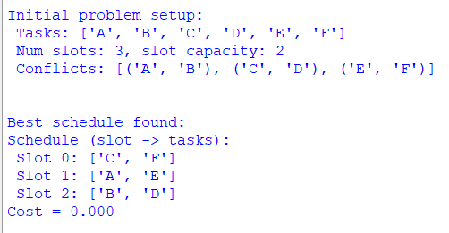

21. Implement a Python program to solve the Knight’s Tour problem using backtracking. The program
should:
a) Represent the chessboard as an N×N grid.
b) Place the knight on a starting square.
c) Recursively attempt to move the knight to all unvisited squares.
d) Backtrack when no legal moves are available.
e) Print the final path if a full tour is found, or report failure otherwise.
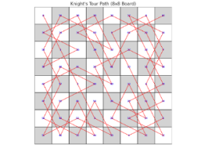
CODE:
# Knight's Tour using Backtracking
N = 8 # size of chessboard (8x8)
def print_solution(board):
for row in board:
print(' '.join(str(cell).rjust(2, ' ') for cell in row))
print()
# Check if (x, y) is a valid move
def is_safe(x, y, board):
return 0 <= x < N and 0 <= y < N and board[x][y] == -1
# Recursive utility to solve Knight's Tour
def solve_knight_tour(x, y, movei, board, x_move, y_move):
# Base case: if all squares are visited
if movei == N * N:
return True

# Try all possible moves from current coordinate (x, y)
for k in range(8):
next_x = x + x_move[k]
next_y = y + y_move[k]
if is_safe(next_x, next_y, board):
board[next_x][next_y] = movei
if solve_knight_tour(next_x, next_y, movei + 1, board, x_move, y_move):
return True
# Backtrack
board[next_x][next_y] = -1
return False

def knight_tour():
# Initialize board
board = [[-1 for _ in range(N)] for _ in range(N)]
# Moves for the knight
x_move = [2, 1, -1, -2, -2, -1, 1, 2]
y_move = [1, 2, 2, 1, -1, -2, -2, -1]

# Start position
board[0][0] = 0

# Start solving from (0, 0)
if not solve_knight_tour(0, 0, 1, board, x_move, y_move):
print("No solution exists.")
else:
print("Knight's Tour Solution Path:")
print_solution(board)

# Run the program
knight_tour()

OUTPUT:
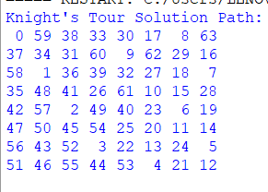

22. Implement a Python program to perform Uniform-Cost Search (UCS) on a weighted graph and validate
its optimality. The program should:
a) Represent the graph as an adjacency list with edge weights.
b) Use a priority queue (min-heap) to always expand the lowest-cost node.
c) Continue expanding nodes until the goal is reached.
d) Print the optimal path and its total cost.
e) Compare the UCS result to a known shortest-path algorithm (e.g., Dijkstra’s) to validate optimality.
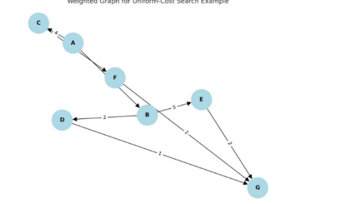
CODE
import heapq
def uniform_cost_search(graph, start, goal):
queue, visited = [(0, start, [])], set()
while queue:
cost, node, path = heapq.heappop(queue)
if node == goal:
return path + [node], cost
if node not in visited:
visited.add(node)
for neighbor, w in graph.get(node, []):
heapq.heappush(queue, (cost + w, neighbor, path + [node]))
return None, float('inf')
def dijkstra(graph, start, goal):
queue, visited = [(0, start, [])], set()
while queue:
cost, node, path = heapq.heappop(queue)
if node == goal:
return path + [node], cost
if node not in visited:
visited.add(node)
for neighbor, w in graph.get(node, []):
heapq.heappush(queue, (cost + w, neighbor, path + [node]))
return None, float('inf')
graph = {
'C': [('A', 1)],
'A': [('F', 4), ('B', 3)],
'F': [('B', 2), ('G', 1)],
'B': [('D', 2), ('E', 5), ('G', 7)],
'D': [('G', 1)],
'E': [('G', 2)],
'G': []
}

ucs_path, ucs_cost = uniform_cost_search(graph, 'C', 'G')
dij_path, dij_cost = dijkstra(graph, 'C', 'G')
print(f"UCS: Path = {ucs_path}, Cost = {ucs_cost}")
print(f"Dijkstra: Path = {dij_path}, Cost = {dij_cost}")

OUTPUT:
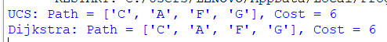

23. Implement a Python program to simulate bilateral negotiation with alternating offers and
discounting. The program should:
a) Represent two agents negotiating over 100 units of a resource.
b) Each agent has a discount factor (0 < δ ≤ 1) to model time preference.
c) Agents take turns proposing offers:
▪ An offer specifies how much of the 100 units each agent receives.
▪ The opponent can accept or reject the offer.
▪ If rejected, negotiation proceeds to the next round with increased discounting.
d) Stop if an agreement is reached or after a maximum number of rounds.
e) Print the final agreement, the utilities of both agents, and indicate if the result resembles a Nash-like fair outcome
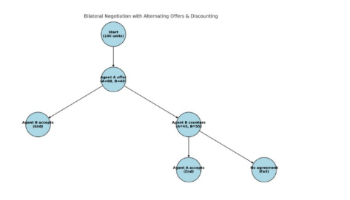
CODE:
"""
Negotiation simulation (alternating offers with discounting) in Pygame

Save as negotiation_pygame.py and run:
python negotiation_pygame.py

Controls (mouse):
- Click the + / - buttons to change delta1/delta2 and max rounds
- Click Start to run the negotiation animation
- Click Reset to reset parameters

The simulation computes the subgame-perfect offers via backward induction (finite horizon)
and animates each round showing the proposer, the offer, acceptance, and final outcome.

Requires: pygame (install via pip install pygame)
"""

import pygame
import sys
import math
from dataclasses import dataclass

# ---- Model parameters ----
R = 100.0

# ---- Backward induction and simulation (same logic as prior text-based version) ----

def compute_backwards(max_rounds: int, delta1: float, delta2: float):
S1 = [(0.0, 0.0) for _ in range(max_rounds + 2)]
S2 = [(0.0, 0.0) for _ in range(max_rounds + 2)]
for t in range(max_rounds, 0, -1):
cont_v2 = S2[t + 1][1]
denom2 = (delta2 ** (t - 1)) if delta2 > 0 else 0.0
if denom2 > 0:
a2_min = cont_v2 / denom2
else:
a2_min = float('inf')
if a2_min <= R:
v1 = (delta1 ** (t - 1)) * (R - a2_min)
v2 = cont_v2
S1[t] = (v1, v2)
else:
S1[t] = S2[t + 1]

cont_v1 = S1[t + 1][0]
denom1 = (delta1 ** (t - 1)) if delta1 > 0 else 0.0
if denom1 > 0:
a1_min = cont_v1 / denom1
else:
a1_min = float('inf')
if a1_min <= R:
v2 = (delta2 ** (t - 1)) * (R - a1_min)
v1 = cont_v1
S2[t] = (v1, v2)
else:
S2[t] = S1[t + 1]
return S1, S2

@dataclass
class RoundState:
round_no: int
proposer: str
offer: tuple | None
accepted: bool

def simulate_steps(max_rounds, delta1, delta2, starter='player1'):
S1, S2 = compute_backwards(max_rounds, delta1, delta2)
history = []
current = starter
for t in range(1, max_rounds + 1):
if current == 'player1':
cont_v2 = S2[t + 1][1]
denom2 = (delta2 ** (t - 1)) if delta2 > 0 else 0.0
a2_min = cont_v2 / denom2 if denom2 > 0 else float('inf')
if a2_min <= R:
a2 = max(0.0, min(R, a2_min))
a1 = R - a2
offer = (a1, a2)
history.append(RoundState(t, 'player1', offer, True))
return history
else:
history.append(RoundState(t, 'player1', None, False))
current = 'player2'
else:
cont_v1 = S1[t + 1][0]
denom1 = (delta1 ** (t - 1)) if delta1 > 0 else 0.0
a1_min = cont_v1 / denom1 if denom1 > 0 else float('inf')
if a1_min <= R:
a1 = max(0.0, min(R, a1_min))
a2 = R - a1
offer = (a1, a2)
history.append(RoundState(t, 'player2', offer, True))
return history
else:
history.append(RoundState(t, 'player2', None, False))
current = 'player1'
return history

# ---- Pygame UI ----

pygame.init()
WIDTH, HEIGHT = 900, 600
screen = pygame.display.set_mode((WIDTH, HEIGHT))
pygame.display.set_caption('Alternating Offers Negotiation (Discounting)')
FONT = pygame.font.SysFont('Arial', 18)
BIGFONT = pygame.font.SysFont('Arial', 24)
CLOCK = pygame.time.Clock()

# Colors
WHITE = (255, 255, 255)
BLACK = (0, 0, 0)
GRAY = (200, 200, 200)
LIGHTGRAY = (230, 230, 230)
GREEN = (44, 160, 44)
RED = (214, 39, 40)
BLUE = (31, 119, 180)

# UI state
delta1 = 0.95
delta2 = 0.90
max_rounds = 15
starter = 'player1'

running_sim = False
sim_history = []
current_step_index = 0
step_timer = 0.0
STEP_DELAY = 1000 # ms between steps

# Buttons and rectangles
start_btn_rect = pygame.Rect(700, 480, 160, 40)
reset_btn_rect = pygame.Rect(700, 530, 160, 40)
plus1_rect = pygame.Rect(240, 80, 30, 30)
minus1_rect = pygame.Rect(200, 80, 30, 30)
plus2_rect = pygame.Rect(240, 140, 30, 30)
minus2_rect = pygame.Rect(200, 140, 30, 30)
plusR_rect = pygame.Rect(240, 200, 30, 30)
minusR_rect = pygame.Rect(200, 200, 30, 30)
starter_toggle_rect = pygame.Rect(200, 260, 120, 30)

def draw_text(text, x, y, font=FONT, color=BLACK):
surf = font.render(text, True, color)
screen.blit(surf, (x, y))

def draw_ui():
# background
screen.fill(WHITE)
# Title
draw_text('Alternating-offers Negotiation (Discounted)', 20, 10, BIGFONT)

# Parameter panel
pygame.draw.rect(screen, LIGHTGRAY, (180, 60, 360, 260))
draw_text('Parameters:', 190, 65, BIGFONT)
# delta1
draw_text('Player1 discount (delta1):', 200, 85)
pygame.draw.rect(screen, GRAY, minus1_rect)
draw_text('-', minus1_rect.x + 9, minus1_rect.y + 5, BIGFONT)
pygame.draw.rect(screen, GRAY, plus1_rect)
draw_text('+', plus1_rect.x + 8, plus1_rect.y + 5, BIGFONT)
draw_text(f'{delta1:.4f}', 290, 85)

# delta2
draw_text('Player2 discount (delta2):', 200, 145)
pygame.draw.rect(screen, GRAY, minus2_rect)
draw_text('-', minus2_rect.x + 9, minus2_rect.y + 5, BIGFONT)
pygame.draw.rect(screen, GRAY, plus2_rect)
draw_text('+', plus2_rect.x + 8, plus2_rect.y + 5, BIGFONT)
draw_text(f'{delta2:.4f}', 290, 145)

# max rounds
draw_text('Max rounds:', 200, 205)
pygame.draw.rect(screen, GRAY, minusR_rect)
draw_text('-', minusR_rect.x + 9, minusR_rect.y + 5, BIGFONT)
pygame.draw.rect(screen, GRAY, plusR_rect)
draw_text('+', plusR_rect.x + 8, plusR_rect.y + 5, BIGFONT)
draw_text(f'{max_rounds}', 290, 205)

# starter
pygame.draw.rect(screen, GRAY, starter_toggle_rect)
draw_text(f'Starter: {starter}', starter_toggle_rect.x + 6, starter_toggle_rect.y + 6)

# Buttons
pygame.draw.rect(screen, BLUE if not running_sim else GRAY, start_btn_rect)
draw_text('Start / Run', start_btn_rect.x + 30, start_btn_rect.y + 12, FONT, WHITE if not running_sim else BLACK)
pygame.draw.rect(screen, RED, reset_btn_rect)
draw_text('Reset', reset_btn_rect.x + 60, reset_btn_rect.y + 12, FONT, WHITE)

# Display negotiation panel
pygame.draw.rect(screen, LIGHTGRAY, (20, 340, 660, 240))
draw_text('Negotiation timeline & outcome:', 30, 345, BIGFONT)

# If simulation has steps, draw them
y0 = 380
if not sim_history:
draw_text('No simulation yet. Adjust parameters and click Start.', 30, y0)
else:
# show up to first 8 rounds
for i, rs in enumerate(sim_history[:8]):
y = y0 + i * 28
text = f"Round {rs.round_no}: Proposer={rs.proposer}"
if rs.offer is None:
text += ' -> Offered nothing (rejected)'
else:
a1, a2 = rs.offer
text += f' -> Offer: P1={a1:.2f}, P2={a2:.2f}'
text += ' [ACCEPT]' if rs.accepted else ' [REJECT]'
draw_text(text, 30, y)

# If agreement reached, display final outcome summary to the right
if sim_history and any(r.accepted for r in sim_history):
# find first accepted
accepted_rounds = [r for r in sim_history if r.accepted]
first = accepted_rounds[0]
a1, a2 = first.offer
# discounted utilities based on round
u1 = (delta1 ** (first.round_no - 1)) * a1
u2 = (delta2 ** (first.round_no - 1)) * a2
draw_text('Final Agreement:', 700, 60, BIGFONT)
draw_text(f'Round: {first.round_no}', 700, 100)
draw_text(f'Proposer: {first.proposer}', 700, 130)
draw_text(f'Allocation: P1={a1:.4f}, P2={a2:.4f}', 700, 160)
draw_text(f'Discounted utilities: U1={u1:.4f}, U2={u2:.4f}', 700, 190)
fair_tol = 5.0
if abs(a1 - R/2) <= fair_tol and abs(a2 - R/2) <= fair_tol:
draw_text('Outcome resembles Nash-like fair (≈50-50)', 700, 220, FONT, GREEN)
else:
draw_text('Outcome NOT close to 50-50 (proposer advantage)', 700, 220, FONT, RED)

def run_simulation():
global sim_history, running_sim, current_step_index, step_timer
sim_history = simulate_steps(max_rounds, delta1, delta2, starter)
running_sim = True
current_step_index = 0
step_timer = pygame.time.get_ticks()

def reset_sim():
global sim_history, running_sim, current_step_index
sim_history = []
running_sim = False
current_step_index = 0

# Helpers for button clicks

def inside(rect, pos):
return rect.collidepoint(pos)

# Main loop

def main_loop():
global delta1, delta2, max_rounds, starter, running_sim, current_step_index, step_timer
while True:
for event in pygame.event.get():
if event.type == pygame.QUIT:
pygame.quit()
sys.exit()
elif event.type == pygame.MOUSEBUTTONDOWN and event.button == 1:
pos = event.pos
if inside(start_btn_rect, pos):
run_simulation()
elif inside(reset_btn_rect, pos):
reset_sim()
elif inside(plus1_rect, pos):
delta1 = min(0.9999, delta1 + 0.01)
elif inside(minus1_rect, pos):
delta1 = max(0.01, delta1 - 0.01)
elif inside(plus2_rect, pos):
delta2 = min(0.9999, delta2 + 0.01)
elif inside(minus2_rect, pos):
delta2 = max(0.01, delta2 - 0.01)
elif inside(plusR_rect, pos):
max_rounds = min(200, max_rounds + 1)
elif inside(minusR_rect, pos):
max_rounds = max(1, max_rounds - 1)
elif inside(starter_toggle_rect, pos):
starter = 'player2' if starter == 'player1' else 'player1'

# update running simulation animation by stepping through history
if running_sim and sim_history:
now = pygame.time.get_ticks()
if now - step_timer >= STEP_DELAY:
# advance to next displayed step if any; here we simply ensure the history is visible -
# since simulate_steps returns only until agreement (or empty), we keep running_sim True
# for a short while then stop
current_step_index += 1
step_timer = now
# stop if we've shown all steps
if current_step_index >= len(sim_history):
running_sim = False

draw_ui()
pygame.display.flip()
CLOCK.tick(30)

if __name__ == '__main__':
main_loop()
OUTPUT:
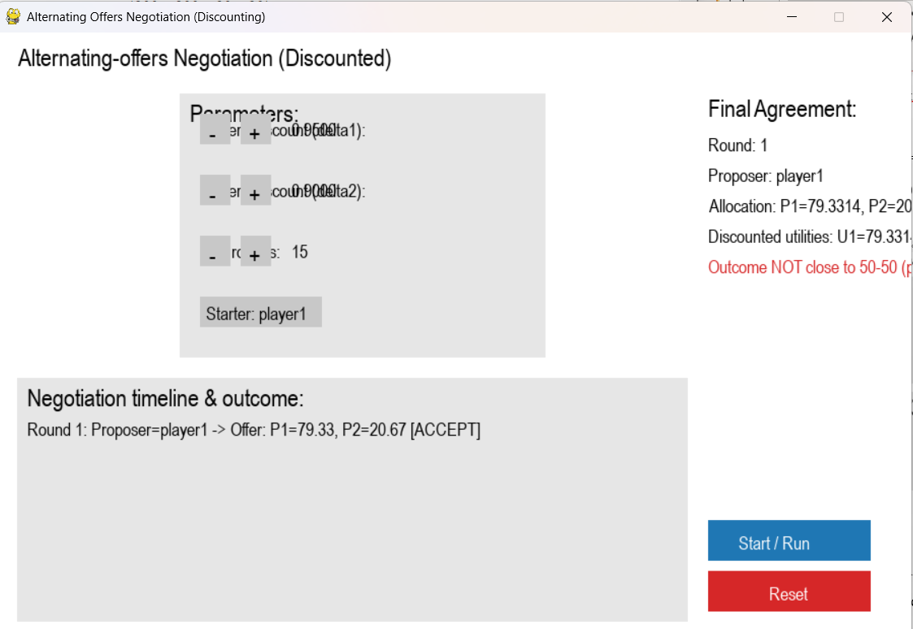

24. Implement a Python program to demonstrate the Expectiminimax algorithm for a stochastic game. The
program should:
a) Build a simple game tree with three types of nodes: Max, Min, and Chance.
b) Assign probabilities to random events at chance nodes.
c) Use recursive Expectiminimax search to compute the expected utility of each node.
d) Print the optimal decision at the root node for the AI player.
e) Show how randomness affects the final choice
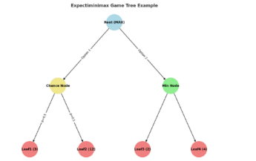
CODE:
def expectiminimax(node, node_type, tree, probabilities=None):
# Leaf node
if isinstance(tree[node], int):
return tree[node]
# MAX node
if node_type == 'max':
return max(expectiminimax(child, tree['types'][child], tree, probabilities) for child in tree[node])
# MIN node
if node_type == 'min':
return min(expectiminimax(child, tree['types'][child], tree, probabilities) for child in tree[node])
# CHANCE node
if node_type == 'chance':
prob_list = probabilities[node]
return sum(
prob * expectiminimax(child, tree['types'][child], tree, probabilities)
for child, prob in zip(tree[node], prob_list)
)

# Example tree structure from the image:
# Root (MAX) --> Chance Node --> Leaf1, Leaf2
# Hit Node --> Leaf3, Leaf4

tree = {
'Root': ['Chance', 'Hit'],
'types': {'Root': 'max', 'Chance': 'chance', 'Hit': 'min', 'Leaf1': 'leaf', 'Leaf2': 'leaf', 'Leaf3': 'leaf', 'Leaf4': 'leaf'},
'Chance': ['Leaf1', 'Leaf2'],
'Hit': ['Leaf3', 'Leaf4'],
'Leaf1': 5,
'Leaf2': 12,
'Leaf3': 15,
'Leaf4': 8
}

# Probabilities for the chance node from the edge labels in the image
probabilities = {
'Chance': [0.5, 0.5] # Probability for Leaf1 and Leaf2
}

# Compute expected utility for both children of the root node
chance_utility = expectiminimax('Chance', tree['types']['Chance'], tree, probabilities)
hit_utility = expectiminimax('Hit', tree['types']['Hit'], tree, probabilities)

print(f"Expected utility of 'Chance' node: {chance_utility}")
print(f"Utility of 'Hit' node (MIN): {hit_utility}")

# Optimal decision at the root (MAX node)
if chance_utility > hit_utility:
print("AI should choose the Chance node.")
else:
print("AI should choose the Hit node.")

print("Randomness affects the choice because the Chance node utility is an average, not a fixed value.")

OUTPUT:
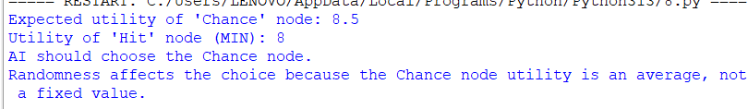
25. Implement a Python program to solve a pathfinding problem using Beam Search. The program
should:
a) Represent the search space as a graph (nodes and weighted edges).
b) Use a heuristic function (e.g., straight-line distance to the goal) to guide the search.
c) Keep only the k most promising nodes (beam width) at each level.
d) Print the path found from the start node to the goal node.
e) Compare results with BFS to show efficiency vs completeness trade-off.
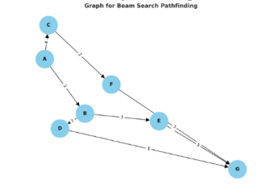
CODE:
from queue import Queue
import heapq

# ----------- Graph Representation -----------
graph = {
'A': {'B': 2, 'C': 4},
'B': {'D': 7, 'E': 3},
'C': {'F': 4, 'G': 5},
'D': {'H': 1},
'E': {'H': 6},
'F': {'G': 2, 'H': 5},
'G': {'H': 3},
'H': {}
}

# ----------- Heuristic Function -----------
# (Straight-line distance or estimated cost to goal)
heuristic = {
'A': 10,
'B': 8,
'C': 7,
'D': 4,
'E': 5,
'F': 3,
'G': 2,
'H': 0
}

# ----------- Beam Search Implementation -----------
def beam_search(start, goal, beam_width):
print(f"\n--- Beam Search (Beam width = {beam_width}) ---")
beam = [(heuristic[start], [start])]
level = 0

while beam:
print(f"\nLevel {level}: Candidates -> {[path[-1] for (_, path) in beam]}")
new_beam = []
for _, path in beam:
node = path[-1]
if node == goal:
print("Goal reached!")
return path
for neighbor, cost in graph[node].items():
new_path = path + [neighbor]
score = heuristic[neighbor]
heapq.heappush(new_beam, (score, new_path))

# Keep only k best nodes
beam = heapq.nsmallest(beam_width, new_beam)
level += 1

print("Goal not found (beam too narrow).")
return None

# ----------- Breadth-First Search (for comparison) -----------
def bfs(start, goal):
print("\n--- Breadth-First Search ---")
visited = set()
queue = Queue()
queue.put([start])

while not queue.empty():
path = queue.get()
node = path[-1]

if node == goal:
return path

if node not in visited:
visited.add(node)
for neighbor in graph[node]:
new_path = path + [neighbor]
queue.put(new_path)

return None

# ----------- Main Function -----------
if __name__ == "__main__":
start = 'A'
goal = 'H'
beam_width = 2 # you can change this to 1, 2, 3, etc.

beam_result = beam_search(start, goal, beam_width)
bfs_result = bfs(start, goal)

print("\nBeam Search Path:", beam_result)
print("BFS Path:", bfs_result)

# ----------- Efficiency vs Completeness Discussion -----------
print("\n--- Comparison ---")
print("Beam Search:")
print("- Faster, memory-efficient, but may miss optimal path if beam width is too small.")
print("BFS:")
print("- Guarantees the shortest path but explores all nodes (less efficient).")

OUTPUT:
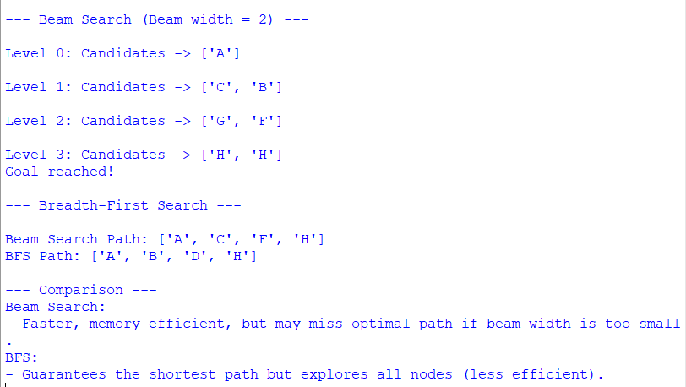

26. Implement a Python program to solve Sudoku as a Constraint Satisfaction Problem using
backtracking search with constraint checking. The program should:
a) Accept a Sudoku puzzle as input (use a 9×9 matrix with 0s for empty cells).
b) Use backtracking to assign values to empty cells.
c) Apply constraints to check row, column, and 3×3 subgrid validity
d) Print the solved Sudoku grid.
CODE:
# Sudoku Solver using Backtracking and Constraint Checking
N = 9 # Sudoku grid size (9x9)

# Function to print the Sudoku grid
def print_grid(grid):
for i in range(N):
for j in range(N):
print(grid[i][j], end=" ")
print()

# Check if placing num at grid[row][col] is valid
def is_safe(grid, row, col, num):
# Row constraint
if num in grid[row]:
return False

# Column constraint
for i in range(N):
if grid[i][col] == num:
return False

# 3x3 Subgrid constraint
start_row = row - row % 3
start_col = col - col % 3
for i in range(3):
for j in range(3):
if grid[start_row + i][start_col + j] == num:
return False

return True

# Find the next empty cell (returns tuple of row, col)
def find_empty_location(grid):
for i in range(N):
for j in range(N):
if grid[i][j] == 0:
return (i, j)
return None

# Backtracking function to solve Sudoku
def solve_sudoku(grid):
empty = find_empty_location(grid)
if not empty:
return True # Puzzle solved

row, col = empty

for num in range(1, 10): # Try numbers 1–9
if is_safe(grid, row, col, num):
grid[row][col] = num # Assign value

if solve_sudoku(grid): # Recursive step
return True

# Backtrack
grid[row][col] = 0

return False

# -------- Main Program --------
if __name__ == "__main__":
# Example Sudoku puzzle (0 = empty)
sudoku_grid = [
[5, 3, 0, 0, 7, 0, 0, 0, 0],
[6, 0, 0, 1, 9, 5, 0, 0, 0],
[0, 9, 8, 0, 0, 0, 0, 6, 0],
[8, 0, 0, 0, 6, 0, 0, 0, 3],
[4, 0, 0, 8, 0, 3, 0, 0, 1],
[7, 0, 0, 0, 2, 0, 0, 0, 6],
[0, 6, 0, 0, 0, 0, 2, 8, 0],
[0, 0, 0, 4, 1, 9, 0, 0, 5],
[0, 0, 0, 0, 8, 0, 0, 7, 9]
]

print("Original Sudoku Puzzle:")
print_grid(sudoku_grid)
print("\nSolving...\n")

if solve_sudoku(sudoku_grid):
print("Solved Sudoku Grid:")
print_grid(sudoku_grid)
else:
print("No solution exists.")

OUTPUT:
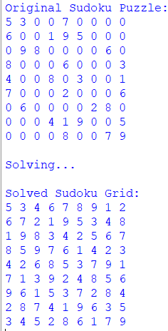
27. Implement a Python program to solve a Grid-World navigation problem using Q-Learning. The
program should:
a) Define a grid environment (e.g., 5×5 grid) with:
▪ A start state.
▪ A goal state with positive reward.
▪ One or more obstacle states with negative reward.
▪ Step penalty for each move to encourage shorter paths.
b) Implement Q-Learning with:
▪ Learning rate (α).
▪ Discount factor (γ).
▪ Exploration rate (ε-greedy strategy).
c) Train the agent for a number of episodes.
d) Print the learned Q-table.
e) Show the optimal path found from start to goal.
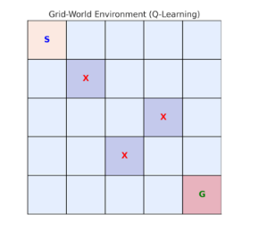
CODE:
import numpy as np
import random

# Define grid world parameters
rows, cols = 5, 5
obstacles = [(1, 1), (2, 3), (3, 2)]
start = (0, 0)
goal = (4, 4)
actions = [(0, 1), (1, 0), (0, -1), (-1, 0)] # Right, Down, Left, Up
action_names = ['R', 'D', 'L', 'U']
step_penalty = -1
obstacle_penalty = -10
goal_reward = 20

# Hyperparams
alpha = 0.1 # Learning rate
gamma = 0.9 # Discount factor
epsilon = 0.2 # Exploration rate
episodes = 500 # Training episodes

# Initialize Q-table
Q = np.zeros((rows, cols, len(actions)))

def valid_state(state):
r, c = state
if 0 <= r < rows and 0 <= c < cols and state not in obstacles:
return True
return False

def get_next_state(current, action):
next_r, next_c = current[0] + action[0], current[1] + action[1]
next_state = (next_r, next_c)
if not valid_state(next_state):
return current # Invalid move, stay in place
return next_state

# Training loop
for episode in range(episodes):
state = start
while state != goal:
r, c = state
# Explore vs exploit
if random.uniform(0, 1) < epsilon:
a = random.randint(0, 3)
else:
a = np.argmax(Q[r, c])

action = actions[a]
next_state = get_next_state(state, action)
nr, nc = next_state

# Rewards
if next_state == goal:
reward = goal_reward
elif next_state in obstacles:
reward = obstacle_penalty
else:
reward = step_penalty

# Q-Learning update
Q[r, c, a] += alpha * (reward + gamma * np.max(Q[nr, nc]) - Q[r, c, a])

state = next_state

# Print Q-table
print("Learned Q-table (shape:", Q.shape, "):")
print(Q)

# Find optimal path from start to goal
state = start
path = [state]
while state != goal:
r, c = state
a = np.argmax(Q[r, c])
next_state = get_next_state(state, actions[a])
if next_state == state or next_state in path:
# Trapped or loop detected
break
path.append(next_state)
state = next_state

print("Optimal path from start to goal:")
print(path)

OUTPUT:
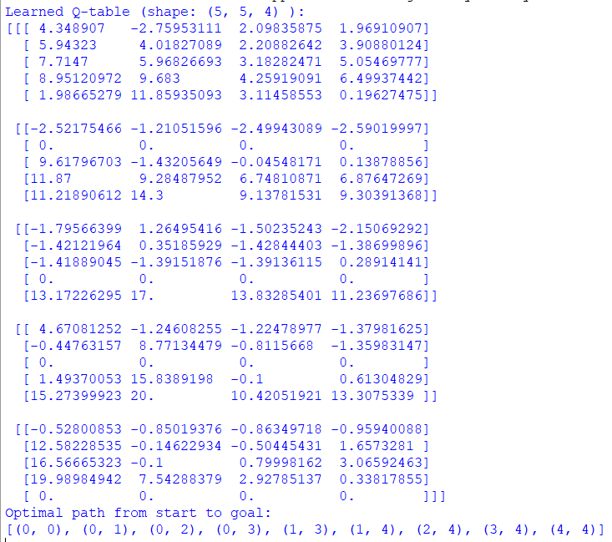

28. Implement a Python program to solve the Travelling Salesman Problem using Ant Colony
Optimization (ACO). The program should:
a) Define a set of cities with pairwise distances (matrix).
b) Simulate ants building tours probabilistically based on pheromone trails and heuristic visibility
(1/distance).
c) Update pheromones each iteration:
▪ Evaporate pheromones globally.
▪ Reinforce pheromones on paths used by ants (especially best tours).
d) Repeat for multiple iterations to converge toward the optimal/near-optimal route.
e) Print the best path and its total cost.
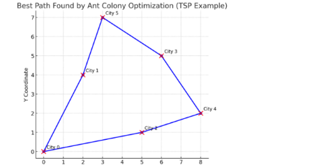
CODE:
import random

# ---------------- Parameters ----------------
NUM_CITIES = 5
NUM_ANTS = 10
ALPHA = 1.0 # pheromone influence
BETA = 5.0 # distance influence
EVAPORATION = 0.5 # pheromone evaporation rate
Q = 100 # pheromone deposit factor
ITERATIONS = 50

# ---------------- Distance Matrix ----------------
distance_matrix = [
[0, 2, 9, 10, 7],
[1, 0, 6, 4, 3],
[15, 7, 0, 8, 3],
[6, 3, 12, 0, 11],
[9, 7, 5, 6, 0]
]

# ---------------- Initialization ----------------
num_cities = len(distance_matrix)
pheromone = [[1 for _ in range(num_cities)] for _ in range(num_cities)]

# Function to compute total tour length
def tour_length(tour):
length = 0
for i in range(len(tour) - 1):
length += distance_matrix[tour[i]][tour[i + 1]]
length += distance_matrix[tour[-1]][tour[0]] # return to start
return length

# Choose next city based on probability
def select_next_city(current_city, unvisited):
total = 0.0
probabilities = []
for city in unvisited:
pher = pheromone[current_city][city] ** ALPHA
visibility = (1.0 / (distance_matrix[current_city][city] + 1e-10)) ** BETA
score = pher * visibility
probabilities.append((city, score))
total += score

# Normalize probabilities
if total == 0:
return random.choice(list(unvisited))
probabilities = [(city, score / total) for city, score in probabilities]

# Roulette wheel selection
r = random.random()
cumulative = 0.0
for city, prob in probabilities:
cumulative += prob
if r <= cumulative:
return city
return probabilities[-1][0]

# ---------------- Ant Colony Optimization ----------------
def ant_colony_optimization():
global pheromone
best_tour = None
best_length = float('inf')

for iteration in range(ITERATIONS):
all_tours = []

for _ in range(NUM_ANTS):
start = random.randint(0, num_cities - 1)
tour = [start]
unvisited = set(range(num_cities)) - {start}

while unvisited:
current_city = tour[-1]
next_city = select_next_city(current_city, unvisited)
tour.append(next_city)
unvisited.remove(next_city)

all_tours.append(tour)

# Find best tour of this iteration
for tour in all_tours:
length = tour_length(tour)
if length < best_length:
best_length = length
best_tour = tour

# Evaporate pheromone
for i in range(num_cities):
for j in range(num_cities):
pheromone[i][j] *= (1 - EVAPORATION)

# Deposit pheromone
for tour in all_tours:
length = tour_length(tour)
deposit = Q / length
for i in range(len(tour) - 1):
a, b = tour[i], tour[i + 1]
pheromone[a][b] += deposit
pheromone[b][a] += deposit
a, b = tour[-1], tour[0]
pheromone[a][b] += deposit
pheromone[b][a] += deposit

print(f"Iteration {iteration+1:02d} | Best Length So Far = {best_length}")

return best_tour, best_length

# ---------------- Main ----------------
if __name__ == "__main__":
best_path, best_cost = ant_colony_optimization()
print("\nOptimal / Best Path Found:")
print(" -> ".join(str(city) for city in best_path) + f" -> {best_path[0]}")
print(f"Total Cost: {best_cost}")

OUTPUT:
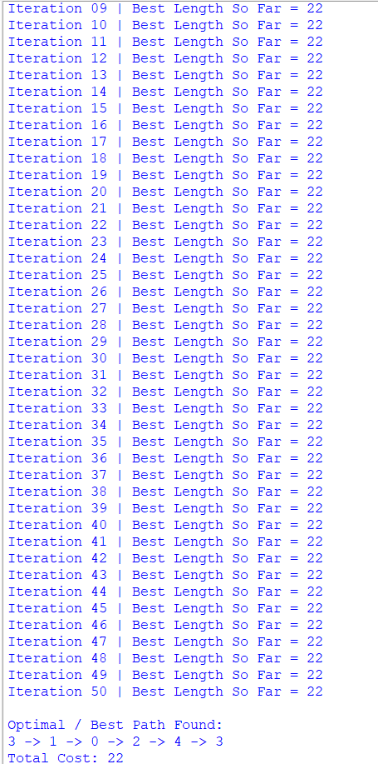

29. Write a Python program to implement a simple Trust and Reputation System for service providers. The
program should:
a) Represent multiple service providers offering services with varying quality.
b) Allow multiple clients/agents to interact with providers and give feedback (positive or negative).
c) Maintain a trust score for each provider based on feedback.
d) Compute reputation as an aggregate of all client trust scores.
e) Allow clients to select providers based on the highest reputation score.
f) Print provider trust scores, reputation values, and the selected best provider.

CODE:
"""
Simple Trust & Reputation System

- Providers have hidden true_quality in [0,1].
- Clients interact with providers and provide binary feedback (1=positive, 0=negative).
- Each client keeps per-provider feedback counts.
- Per-client trust score for provider p: (pos + 1) / (pos + neg + 2) (Beta(1,1) prior -> Laplace smoothing)
- Provider reputation: mean of all clients' trust scores for that provider.
- Clients choose provider with highest reputation when selecting.
"""

import random
from collections import defaultdict
from typing import Dict, List, Tuple

random.seed(123) # reproducible demo

class Provider:
def __init__(self, pid: int, true_quality: float):
self.id = pid
self.true_quality = float(true_quality) # probability of delivering positive experience
self.global_pos = 0
self.global_neg = 0

def deliver_service(self) -> int:
"""Return 1 for positive experience, 0 for negative (stochastic using true_quality)."""
return 1 if random.random() < self.true_quality else 0

class Client:
def __init__(self, cid: int):
self.id = cid
self.feedback_counts: Dict[int, List[int]] = defaultdict(lambda: [0, 0])

def give_feedback(self, provider: Provider, outcome: int):
"""Record client feedback for provider (outcome=1 or 0)"""
if outcome == 1:
self.feedback_counts[provider.id][0] += 1
provider.global_pos += 1
else:
self.feedback_counts[provider.id][1] += 1
provider.global_neg += 1

def trust_score_for(self, provider_id: int) -> float:
"""Compute per-client trust estimate for a provider with Laplace smoothing."""
pos, neg = self.feedback_counts.get(provider_id, [0, 0])
return (pos + 1) / (pos + neg + 2) # Beta(1,1) posterior mean

class TrustReputationSystem:
def __init__(self):
self.providers: Dict[int, Provider] = {}
self.clients: Dict[int, Client] = {}

def add_provider(self, pid: int, true_quality: float):
self.providers[pid] = Provider(pid, true_quality)

def add_client(self, cid: int):
self.clients[cid] = Client(cid)

def run_interaction(self, client: Client, provider: Provider):
"""One interaction: service delivered, client records feedback."""
outcome = provider.deliver_service()
client.give_feedback(provider, outcome)

def compute_reputation(self, provider_id: int) -> float:
"""Aggregate reputation as mean of all clients' trust scores for this provider."""
if not self.clients:
return 0.0
scores = [client.trust_score_for(provider_id) for client in self.clients.values()]
return sum(scores) / len(scores)

def select_best_provider(self) -> Tuple[int, float]:
"""Select provider with highest reputation; return (pid, reputation)."""
best_pid, best_rep = None, -1.0
for pid in self.providers:
rep = self.compute_reputation(pid)
if rep > best_rep:
best_pid, best_rep = pid, rep
return best_pid, best_rep

def simulate(self, rounds: int, interactions_per_round: int = 1):
"""Each round: each client selects a provider (by current reputation) and interacts."""
for r in range(1, rounds + 1):
client_ids = list(self.clients.keys())
random.shuffle(client_ids)
for cid in client_ids:
client = self.clients[cid]
best_pid, _ = self.select_best_provider()
if best_pid is None:
best_pid = random.choice(list(self.providers.keys()))
provider = self.providers[best_pid]
for _ in range(interactions_per_round):
self.run_interaction(client, provider)

def print_status(self):
print("=== Providers summary ===")
for pid, prov in self.providers.items():
rep = self.compute_reputation(pid)
print(f"Provider {pid}: true_quality={prov.true_quality:.3f}, global_pos={prov.global_pos}, global_neg={prov.global_neg}, reputation={rep:.4f}")
print(" Per-client trust scores:")
for cid, client in self.clients.items():
t = client.trust_score_for(pid)
print(f" Client {cid}: trust={t:.4f} (pos,neg)={client.feedback_counts.get(pid, [0,0])}")
best_pid, best_rep = self.select_best_provider()
if best_pid is not None:
print(f"\nSelected best provider by reputation: Provider {best_pid} with reputation {best_rep:.4f}")
else:
print("\nNo providers available.")

def demo():
# create system
sys = TrustReputationSystem()

# Add providers (id, true_quality)
sys.add_provider(1, 0.85) # high-quality provider
sys.add_provider(2, 0.60) # medium-quality
sys.add_provider(3, 0.35) # low-quality

# Add clients
num_clients = 8
for cid in range(1, num_clients + 1):
sys.add_client(cid)

# Initial state print (no interactions)
print("Initial state (no interactions):")
sys.print_status()
print("\n--- Running simulation: clients pick best provider by current reputation and interact ---\n")

# Run simulation: many rounds so reputations converge
sys.simulate(rounds=30, interactions_per_round=1)

# Final status
print("\nFinal status after simulation:")
sys.print_status()

# Show some extra summary
print("\nDetailed provider reputations (rounded):")
for pid in sys.providers:
print(f" Provider {pid}: Reputation = {sys.compute_reputation(pid):.3f}")

if __name__ == "__main__":
demo()

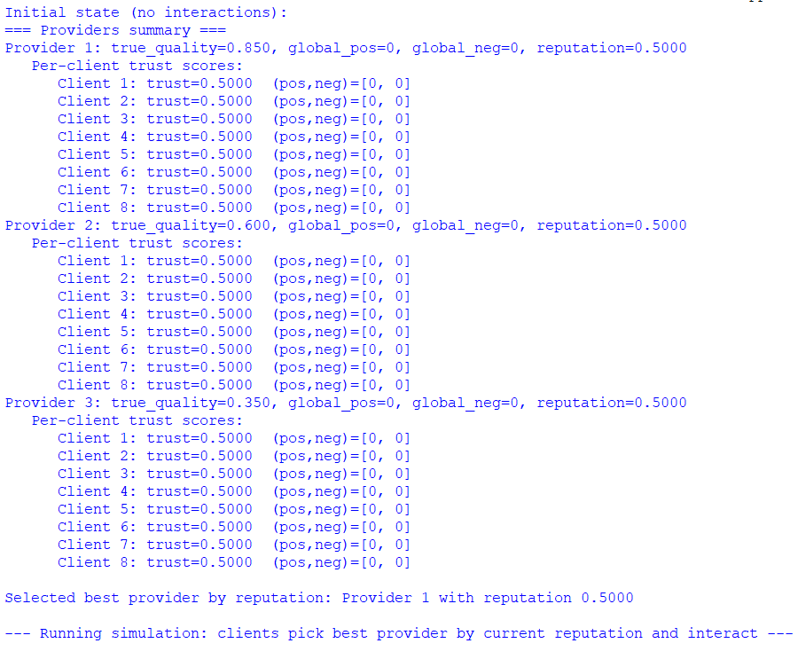

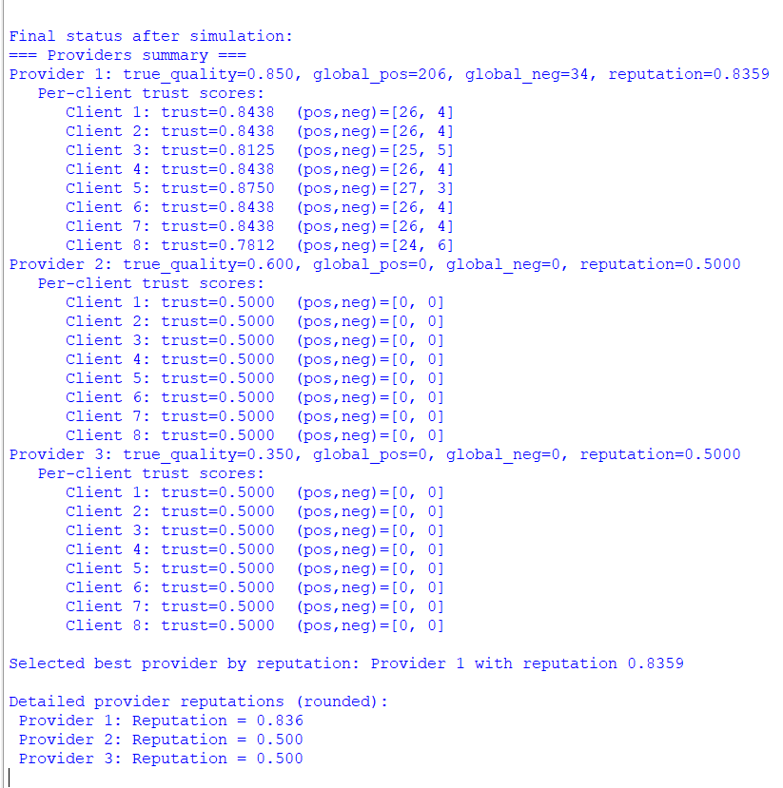

30. Write a Python program to:
a) Parse ontology triples representing subclass relationships.
b) Build a knowledge graph (dictionary-based).
c) Support queries like:
▪ Find all subclasses of a given class.
▪ Check if one class is a subclass of another (directly or indirectly).
d) Print the results clearly.
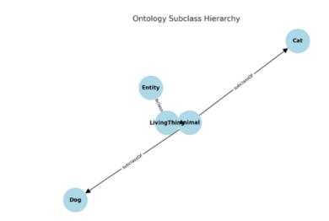
CODE:
# ---------------- Ontology Graph Builder ----------------

# Example ontology triples (subject, predicate, object)
triples = [
("Dog", "rdfs:subClassOf", "Mammal"),
("Cat", "rdfs:subClassOf", "Mammal"),
("Mammal", "rdfs:subClassOf", "Animal"),
("Animal", "rdfs:subClassOf", "LivingBeing"),
("Fish", "rdfs:subClassOf", "Animal"),
("Shark", "rdfs:subClassOf", "Fish"),
]

# ---------------- Build Knowledge Graph ----------------
def build_knowledge_graph(triples):
graph = {}
for subj, pred, obj in triples:
if pred == "rdfs:subClassOf":
if obj not in graph:
graph[obj] = set()
graph[obj].add(subj)
return graph

# ---------------- Query Functions ----------------

# Find all subclasses (direct + indirect)
def find_all_subclasses(graph, superclass):
subclasses = set()
direct = graph.get(superclass, set())

for sub in direct:
subclasses.add(sub)
subclasses |= find_all_subclasses(graph, sub) # recursive call

return subclasses

# Check if one class is subclass of another
def is_subclass(graph, subclass, superclass):
# Direct subclass?
if subclass in graph.get(superclass, set()):
return True

# Check indirect subclasses recursively
for sub in graph.get(superclass, set()):
if is_subclass(graph, subclass, sub):
return True
return False

# ---------------- Main ----------------
if __name__ == "__main__":
graph = build_knowledge_graph(triples)
print("Knowledge Graph (Superclass → Subclasses):")
for key, value in graph.items():
print(f" {key} → {', '.join(value)}")

print("\n--- Queries ---")

# Query 1: Find all subclasses of 'Animal'
target_class = "Animal"
result = find_all_subclasses(graph, target_class)
print(f"All subclasses of '{target_class}': {', '.join(sorted(result))}")

# Query 2: Check subclass relationship
subclass, superclass = "Dog", "LivingBeing"
print(f"\nIs '{subclass}' a subclass of '{superclass}'? → {is_subclass(graph, subclass, superclass)}")

subclass, superclass = "Shark", "Mammal"
print(f"Is '{subclass}' a subclass of '{superclass}'? → {is_subclass(graph, subclass, superclass)}")

OUTPUT:
